

IMAGE SEGMENTATION TECHNIQUE
FOR AUTOMATIC DETECTION
CLASSIFICATION OF AGRICULTURAL
DISEASE USING MATLAB

A PROJECT REPORT
Submitted by

DHIWAHAR V | 611621406017
ABINAYAN V | 611621406001
GOKILAN S | 611621406023

In partial fulfillment for the award of the degree of

BACHELOR OF ENGINEERING
IN
ELECTRONICS AND COMMUNICATION ENGINEERING

DEPARTMENT OF ELECTRONICS AND COMMUNICATION ENGINEERING
MAHENDRA INSTITUTE OF TECHNOLOGY
(Autonomous)
Mahendhirapuri, Mallasamudram, Namakkal DT-637 503
MAY 2025

MAHENDRA INSTITUTE OF TECHNOLOGY
(Autonomous)

Mahendhirapuri, Mallasamudram,Namakkal DT-637503

Department of Electronics and Communication Engineering

BONAFIDE CERTIFICATE

Certified that this project report “IMAGE SEGEMETATION TECHNIQUE FOR AUTOMATIC DETECTION CLASSIFICATION OF AGRICULTURAL DISEASE USING MATLAB” is the bonafide work of “DHIWAHAR A (611620406017), ABINAYAN V(611621406001), GOKILAN S N(611621406023)” who carried out the work under my supervision.

SIGNATURE | SIGNATURE
Dr. S. PRABU, M.E., Ph.D., | Dr. V.ELLAPPAN, M.E., Ph.D.,
HEAD OF THE DEPARTMENT | SUPERVISOR
Professor & Head | Assistant Professor
Department of Electronics and | Department of Electronics and
Communication Engineering | Communication Engineering
Mahendra Institute of Technology | Mahendra Institute of Technology
(Autonomous) | (Autonomous)
Namakkal-637 503 | Namakkal-637 503

MAHENDRA INSTITUTE OF TECHNOLOGY
(Autonomous)

Mahendhirapuri, Mallasamudram, Namakkal DT 637-503
Department of Electronics and Communication Engineering

CERTIFICATE OF PROJECT APPROVAL

This is to certify that the Project report titled “IMAGE SEGMENTATION TECHNIQUE FOR AUTOMATIC DETECTION AND CALSSIFICATION OF AGRICULTURE DISEASE USING MATLAB” is the approved record of work done “DHIWAHAR A (611621406017), ABINAYAN V (611621406001), GOKILAN S(611621406023), ”in partial fulfillment for the award of the Degree of B.E Electronics and Communication Engineering during the academic year in 2021-2025.

SUPERVISOR HEAD OF THE DEPARTMENT

(Signature with seal)

Date:

Submitted for the end semester viva voce examination held on ………………………..

INTERNAL EXAMINER EXTERNAL EXAMINER
ACKNOWLEDGEMENT
We would like to take this opportunity to say our thanks to the people who have helped us make this project a reality.
We wish to express our sincere thanks to our honorable chairman, Shri. M. G. BHARATH KUMAR B.Ed., M.A., M.I.S.T.E., of our Educational trust, Kalipatti and the Managing Directors Er.Ba. MAHENDIRAN B.E., and Er. MAHA AJAY PRASAD B.E., providing an extraordinary infrastructure.
We would like to express our sincere thanks to Dr. T. ELANGO M.E., Ph.D., the principal of our college, for their kind encouragement and blessings to do this project.
We also thank Dr. S. PRABU M.E., Ph.D., Head of the Department, Department of Electronics and Communication Engineering for the encouragement, valuable suggestions and support in doing this project.

We record my deep sense of the thanks to our coordinator S.KARTHICK ME.PHD, Associate Professor, Department of Electronics and Communication Engineering for his valuable support. We would like to thank our Project supervisor Dr.V.ELLAPPAN.ME.PHD Assistant Professor Department of Electronics and Communication Engineering for the kind co-operative and support rendered in making our project as success.
I would like to extend my sincere thanks to all lab technicians for helping me in this venture, Unfiniching support and encouragement from the members of my family, friends and staff of MAHENDRA INSTITUTE OF TECHNOLOGY (AUTONOMOUS).

ABSTRACT

“Image Segmentation Technique for Automatic Detection and

Classification of Agricultural Disease Using MATLAB”

The foundation of providing cultures with the primary means of subsistence and economic growth is Agriculture. In India, agriculture is the backbone as it contributes
16% of the overall GDP and accounts for employment of approximately 52% of the Indian population. Moreover, it is deeply intertwined with various sectors such as agribusiness, technology which continuously strive to enhance productivity, sustainability, and resilience in the face of environmental changes. As agriculture is the backbone and many of the crops are destroyed or significantly affected by disease but with the use of Image Processing Technique, disease in plant leaves can be detected. Image processing techniques can be used to analyze the image of a plant leaf and identify patterns or characteristics that are indicative of disease presence. Automatic leaf disease detection is a crucial area of agricultural research. It may be applicable in monitoring large fields of crops, and thus automatically detect symptoms of disease by the leaves of plants. This work presents an important method to develop for detecting plant disease. Agricultural productivity is something on which the economy highly depends. This is one of the reasons that disease detection in plants plays an important role in the agriculture field, as having disease in plants is quite natural. If proper care is not taken in this area then it causes serious effects on plants and due to which respective product quality, quantity and productivity is affected.
Detection of plant disease through some automatic technique is beneficial as it reduces a large work of monitoring in big farms of crops, and at a very early stage itself it detects the symptoms of diseases i.e. when they appear on plant leaves. Images are having higher quality and clarity than original captured images after enhancing. Different real time applications such as remote sensing, medical image analysis and plant leaves disease detection are used by computer vision image enhancement (Color conversion and Histogram equalization). Original captured images are RGB images. RGB images are a combination of primary colors (Red, Green and Blue). The range of this color is 0 to 255 so it has become difficult to implement applications.

image application implementation is easy because it has a range between 0 and 1. Histogram equalization increases the image clarity. Further plant leaf disease detection is used by grayscale conversion and histogram equalization. In agriculture research of automatic leaf disease detection is an important research topic. It may be applicable in monitoring large fields of crops, and thus automatically detect symptoms of disease by the leaves of plants. The term disease is usually used only for destruction of live plants. This work presents an important method to develop for detecting plant disease. The methods studied are for increasing throughput and accurate treatment of plant disease than human prediction.
Digital image processing is a technique used for enhancement of the image. Image enhancement is a process to remove the unwanted distortion due to deterioration in contrast, unwanted noise, improper intensity saturation, blurring effect etc., and determine the hidden information that are contained in images. And image enhancement gives better visual images that are given as input to various digital image processing applications. At present, the work is only concentrated on the contrast enhancement of digital images that can be used in different applications like biometric analysis, pattern identification, facial acknowledgement, medical fields, and in consumer electronics applications. Contrast is an image element that could be defined as a ratio between the highest and the lowest pixel intensities of an image. In an image processing system contrast enhancement is a strenuous task to be done as well as it is very difficult to obtain a good contrast image. There are several descriptions for an image to have poor contrast: due to the poor quality of the used imaging device. The images usually suffer from poor image quality, degradation in contrast and happening of shading and artifacts, due to lack in centering pixel intensity, poor lightening, specimen spotting and other factors that can be manipulated by image enhancement methods To improve agricultural products automatic detection of symptoms is beneficial.
This thesis presents an algorithm for image segmentation technique which is used for automatic detection and classification of plant leaf diseases. It also covers surveys on different disease classification techniques that can be used for plant leaf disease detection. Image segmentation, which is an important aspect for disease
detection in plant leaf disease, is done by using genetic algorithms.

TABLE OF CONTENT

CHAPTER NO | TITLE |  |  | PAGE NO
 | ABSTRACT |  |  | V  vi
 | LIST OF TABLES |  |  | X
 | LIST OF FIGURES |  |  | Xi
 | LIST OF ABBREVATIONS |  |  | Xii
1 | INTRODUCTION
 | 1.1 | OVERVIEW |  | 14
 | 1.2 | HISTORY OF DIGITAL IMAGE PROCESSING |  | 15
 |  | 1.2.1 | Bartlane cable transmission system | 17
 | 1.3 | IMAGE PROCESSING |  | 17
 | 1.4  1.5  1.6 | COMPONENTS OF DIP SYSTEM  FUNDAMENTALS STEPS IN  SYSTEM  IMAGE PROCESSING TECHNOLOGY IN AGRICULTURE FIELD |  | 18  19  21
 | 1.7 | SIZE AND PREDICTION OF GLOBALSMART AGRICULTURE SECTOR 2016-2024 |  | 23
 | 1.8  1.9  1.10 | MOTIVATION  OBJECTIVE OF THE THESIS  DISSERTATION ORGANIATION |  | 25  25  26
2 | LITERATURE REVIEW
 | 2.1 | BACKGROUND |  | 28
 | 2.2 | METHODS OF DISEASE DETECTION |  | 28
 |  | 2.2.1 | Convolutional Neural Network | 29
 |  | 2.2.2 | By Deep learning method with convolution neural network (CNN) | 30
 |  | 2.2.3 | K- Clustering methodology | 31
 | 2.3 | Comparison based on Existing Algorithms |  | 31
3 | DETECTION AND CLASSIFICATION OF AGRICULTURAL LEAF DISEASES USING HISTOGRAM TECHNIQUE
 | 3.1 | INTRODUCTION |  | 41
 |  | 3.1.1 | Biology point of view | 43
 | 3.2 | BIOLOGY POINT OF VIEW |  | 44
 |  | 3.2.1 | Colour transformation structure | 44
 |  | 3.2.2  3.2.3  3.2.4  3.2.5 | Segmentation  Colour co-occurrence method  Fliters  Histogram equalization | 45  45  45  46
4 | EXPERIMENTAL RESULT AND DISCUSSION
 | 4.1 | IMPLEMENTATION DETAILS |  | 48
 | 4.2 | PERFORMANCE PARAMETERS |  | 49
 |  | 4.2.1 | Software Implementation detail MATLAB | 50
 | 4.3  4.4 | RESULT ANALYSIS  OUTPUT |  | 52  54
5 | CONCLUSION AND FUTURE WORK
 | 5.1 | CONCLUSION |  | 58
6 | REFERENCE |  |  | 59

LIST OF FIGURES
FIGURE NO | TITLE | PAGE NO
2.1 | Phases of plant disease detection system | 27
2.2 | By Deep learning method with convolution neural network (CNN) | 28
2.3 | K- Clustering Algorithm | 29
3.1 | Image of infected leaf affected by the pathogens | 39
3.2 | Leaf features | 40
3.3 | Block diagram of proposed approach | 41
3.4 | Bacterial diseases in Rose Leaf (Unhealthy leaf) | 44
4.1 | Shows the Rose healthy used in the experiment | 50
4.2 | Shows the Histogram of Rose healthy leaf  In which Y-Axis represents the intensity | 50
4.3 | Shows the rose healthy used in the  experiment | 51
4.4 | Shows the Histogram of Rose healthy leaf in which Y-Axis represents the intensity whereas X-Axis represents the tonal | 51
4.5 | Shows the Unhealthy Rose leaf used in the  experiment | 52
4.6 | Shows the Histogram of Unhealthy Rose leaf in which Y-Axis represents intensity whereas X-Axis shows represents the tonal | 52
4.7 | Shows the Rose Unhealthy used in the experiment | 53
4.8 | Shows the Histogram of Unhealthy Rose leaf in which Y-Axis represents intensity whereas X-Axis shows represents the tonal | 53
4.9 | Shows the Tomato healthy used in the experiment | 54
4.10 | Shows the Histogram of Tomato healthy leaf in which Y-Axis represents the intensity whereas X-Axis represents the tonal | 54
4.11 | Shows the Tomato healthy used in the experiment | 55
4.12 | Shows the Histogram of Tomato healthy leaf in which Y- Axis represents the intensity whereas X-Axis represents the tonal | 55
4.13 | Shows the Unhealthy Tomato leaf used in the experiment | 56
4.14 | Shows the Histogram of Unhealthy Tomato leaf in which Y-Axis represents intensity whereas X-Axis shows represents the tonal | 57
4.15 | Shows the Unhealthy Tomato leaf used in the experiment | 57

CHAPTER-1
INTRODUCTION

1.1 Overview
The agricultural land mass has several uses in the modern world, beyond only producing food. Productivity in agriculture has a major role in the Indian economy. As a result, plant disease identification is crucial in the agricultural industry. Using an automated disease detection approach can help identify plant diseases in their very early stages. The current approach for detecting plant diseases involves professionals identifying and detecting the illnesses with their naked eyes [1]. This requires constant plant monitoring and a sizable staff of specialists, both of which are quite expensive when dealing with huge farms. Simultaneously, farmers in many nations lack enough infrastructure and even the knowledge that they may consult professionals. Because of this, seeking the advice of specialists may be expensive and time-consuming. Under these circumstances, the recommended method works well for keeping an eye on big agricultural fields. In addition to being simpler and less expensive, automatic disease diagnosis is achieved by just observing the symptoms on plant leaves. Additionally, this allows machine vision to offer robot guiding, inspection, and autonomous process control based on images. Visual diagnosis of plant diseases is more time-consuming, less accurate, and only practical in certain situations. On the other hand, using an automated detection approach will save time, effort, and improve accuracy. Image processing is utilised to quantify disease-affected regions and ascertain the variation in colour of the afflicted area.

The technique of splitting or organising a picture into distinct sections is known as image segmentation. There are several picture segmentation techniques available today, ranging from basic holdover approaches to sophisticated colour image segmentation techniques. These components often relate to things that are simple for individuals to distinguish and perceive as distinct entities. [2, 3]. Since computers are incapable of sophisticated object recognition, a wide variety of techniques have been devised to segment pictures. The image different attributes serve as the basis for the segmentation procedure. This might include picture segments, borders, or colour information. For segmenting colour images, we employ the genetic algorithm. I. Rechenberg originally presented evolutionary computing in the 1960s. Other researchers later developed his theory. Even though they might not seem like much at first, evolutionary changes occasionally have a big impact on natural selection and the survival of the species.

Productivity in agriculture is important for economic expansion. Given how frequently diseases affect plants, one of the core reasons why plant disease recognition is so important in the agricultural industry. In India, agriculture supports 70% of the population. Farmers can choose from a wide variety of fruit and vegetable crops. If necessary, precautions are not followed in this region, plants suffer major consequences that have might have an influence on the quality, quantity, or productivity of the corresponding products. Diseases can significantly affect crop productivity and lead to lower yields and lower-quality agricultural output [4].

A number of factors, including disease kind, crop susceptibility, environmental conditions, and management strategies, may influence how diseases impact agricultural productivity. The use of an automatic approach for plant disease detection is advantageous because it reduces the amount of labour required to monitor large crop farms and can identify illness. It also identifies disease indications at the very early stage, i.e., when they appear on plant leaves.

1.2 History of Digital Image Processing

When pictures were initially sent between London and New York via undersea cable, the newspaper business was one of the first to exploit digital image data. The time it took to send an image across the Atlantic dropped from more than a week to less than three hours with the advent of the Bartlane cable picture transmission system in the early 1920s. After being encoded for cable transmission, images were printed with specialised equipment and then reconfigured. Some of the early difficulties in improving the visual quality of these early digital images were related to the choice of printmakers and the distribution of intensity levels. In addition, because processing digital images requires so much computing power and storage, progress in the field of digital imaging has depended on the growth of digital computers and related technologies such as data storage, display, and During the 1940s, when the first digital computers were developed, digital imaging get started. At the National Bureau of Standards, Russell Kirsch developed the first digital image processing system in 1957. Using this procedure, the photos were scanned using a drum scanner and then processed on a computer. The invention of the charge-coupled device (CCD) in 1969 completely changed how digital pictures are produced. Semiconductor devices called CCDs have the ability to transform light into electrical impulses. Thus, it is possible to shoot digital images with more accuracy and detail than ever before.

This method used a drum scanner to scan the images, which were then processed on a computer. The charge-coupled device (CCD), which was created in 1969, revolutionized the creation of digital images. CCDs are semiconductor devices that can convert light into electrical impulses. Digital photos may thus be taken more precisely and in greater detail than ever before.

In the 1970s, digital image processing techniques were developed for use in satellite imaging, medical imaging and remote sensing. These techniques made it possible to look for patterns and characteristics in an image analysis. This led to the development of computer vision, which is the capacity of a computer to examine and understand digital images. The 1990s saw the development of digital image processing techniques for image segmentation and object detection. These algorithms allowed for the recognition of objects in digital images and the data extraction from them. As a result, automated techniques for processing images were developed for use in facial recognition and other fields [5].

1.2.1 Bartlane Cable Transmission System

The Bartlane Cable System was introduced by the Bartlane Corporation in the late1950s.
It was developed to provide a more trustworthy and secure method of transmitting data across large distances. The system combined microwave links and coaxial wires to transmit data over long distances. Although some private enterprises also used the system, it was mostly used for communications between the government and the military.

The Bartlane cable image transmission system, a type of cable television system, transmits visual signals via coaxial wires. To operate the system, a signal must be transmitted from a transmitter to a receiver. The signal is then amplified and sent over cable to the television. The signal is then amplified and sent over cable to the television. After decoding the signal, the television displays the image on the screen. The technology may transfer signals in both digital and analogue formats. The transmission system is a method for transmitting images through a cable network. It was produced by the Bartlane Corporation in the early 1990s.

To operate the device, the image is transformed into a digital format and transmitted via the cable network. The image is then encoded and displayed on a monitor at the other end. The method allows for the transmission of high-resolution images at rates of up to 10 megabits per second. The Bartlane system uses a technique called "time division multiplexing" to transmit the visual data. Using this technique, the image is split into smaller pieces and supplied one packet at a time. Each packet is sent at a specific time, enabling quick and efficient image transmission. The system also uses error-correction techniques to ensure error-free image delivery [6].

1.3 Image processing

Digital image processing is the technology of processing digital images using a variety of computer methods. This procedure can produce images or a collection of representative qualities or properties of the source images. Applications for digital image processing are often found in robotics,intelligent systems, medical imaging, remote sensing, photography, and forensics. DIP is concerned with an image that is made up multiple image points.

Fig. 1.1 Process diagram of Digital image processing

These image points, also known as pixels, include spatial coordinates that specify their position in image as well as intensity (or gray level) values. A colourful image contains more dimensional information than a gray image because red, green, and blue values are generally used in diverse combinations to reproduce the image's hues in real life.

1.4 Components of DIP system

• Image sensors: To acquire a digital image, two sensory elements are required. The first is a physical device that detects the energy produced by the object to be imaged and the second is specialized imaging hardware.

• Special image processing hardware: Consists of the above-mentioned digitizer, as well as equipment that performs other primitive image operations, such as an arithmetic logic unit, which performs arithmetic operations such as addition and subtraction, as well as logic operations in parallel on images.

• Computer: General-purpose computers that, depends on the application, can range from PCs to supercomputers. In special applications, specially designed computers are sometimes used to achieve the desired level of performance.

• Software: A well-designed package also includes the ability for users to write code that uses at least custom modules. These modules can be integrated into more sophisticated software packages.

• Mass Storage: This feature is essential for image processing applications. An uncompressed image of 1024 x 1024 pixels would require 1MB of storage because each pixel has 8 bits of intensity.

• Image Display: This feature is important in image processing applications. An uncompressed image of size 1024 x 1024 pixels would require 1MB of storage because each pixel
has 8 bits of intensity.

• Hardware Devices: Digital devices such as laser printers, film cameras, thermal inkjet devices, optical disks, and CD ROMs are some of the image recording equipment.

• Networking: Due to large amount of data required by image processing programs, this is almost a default feature on all computer systems today. Bandwidth for image transmission is a major factor.

Fig. 1.2 Components of a Digital image processing system

1.5 Fundamentals steps in DIP system

• Image acquisition- It could be as simple as already receiving a digital image.

Fig. 1.3 Steps involve in DIP

• Image enhancement - It is among the simplest and most interesting features of enhancing digital images. The idea is to bring out obscured details in the image, or

simply highlight specific features of interest. Image enhancement is a very personal aspect of image processing.

• Image restoration- Enhancing the image look is the aim. This is an objective approach in that image restoration techniques typically rely on mathematical or probabilistic image processing models. In contrast, enhancement is based on humans' subjective preferences for what constitutes a “good” enhancement outcome.

• Colour image processing- This is a growing field due to the widespread use of digital images on the Internet. Colour image processing is primarily concerned with colour models and their implementation in image processing applications.

• Wavelets and Multiresolution Processing-These serve as the foundation for representing images of varying resolutions.

Fig. 1.4 Image restoration example

• Compression- It is concerned with techniques for reducing the amount of storage required to save an image or the amount of bandwidth required to transmit it over a network. It must take major approaches.

1. Compression without loss
2. Compression with Loss

• Morphological processing- It deals with methods for removing parts of a picture that are helpful for describing and representing the form and boundaries of an item. It is most commonly found in automated inspection applications.

• Representation and Description- It always comes after the output of the segmentation step, which is raw pixel data that represents either the boundary of an image or points within the region itself. In either case, the data must be converted to a format suitable for computer processing.

• Recognition- It is the process of labelling an object using its descriptors. It is the final stage of image processing that employs artificial intelligence software.

• Knowledge base- In the form of a knowledge base, knowledge about a problem domain is coded into an image processing system. This knowledge could be as simple as highlighting regions of an image where the relevant information is known to be located. As a result, the amount of time spent searching for information is reduced. A knowledge base can also be quite complex, such as an image database containing high resolution satellite images of a region in connection with a change detection application, or an interconnected list of all major possible defects in a materials inspection problem.

1.6 Image processing technology in Agricultural field

Image processing technology can be utilized in agriculture in a variety of ways to improve productivity, efficiency, and decision-making. Here are several examples:

• Crop health monitoring- To monitor the health of the crops, aerial or satellite images of agricultural fields can be examined using image processing techniques. By examining the photos, farmers can find early signs of diseases, nutrient shortages, or insect infestations. This enables quick intervention and targeted therapy, which increases agricultural production.

• Weed detection and management- Image processing may be utilised to differentiate weeds from crops in the field. By examining images captured by cameras or drones, farmers may precisely identify and map weed populations. This knowledge makes it possible to apply herbicides precisely, reducing the need for excessive chemical use and minimizing any unfavorable environmental impacts.

• Crop yield estimation- Image processing can aid in yield estimation by looking at pictures of the fields. Plant density, fruit size, and other factors can be used by farmers to anticipate yields and determine the optimum methods for harvesting, storing, and marketing.

• Soil analysis: Image processing techniques may be employed to evaluate the characteristics and states of the soil. Images of soil samples can be processed to learn details about soil
characteristics like moisture content, organic matter concentration, soil texture, and nutrient levels. This knowledge can help farmers make informed decisions about their soil management, fertilization, and irrigation plans.

• Management of irrigation- By evaluating thermal images captured by drones or satellite sensors, image processing can help pinpoint fields that require irrigation. Changes in plant temperature that indicate changes in moisture content can be detected via thermal imaging. As a result, farmers may optimum their irrigation plans, conserve water, and prevent either under- or over-irrigating their crops.

• Plant Phenotyping- meaning the examination of a plant's traits and characteristics, can be aided by image processing. By collecting photographs of plants at various stages of growth, algorithms can acquire information on plant height, leaf area, biomass, and other elements. Uses for this information include crop breeding, genetic analysis, and enhancing plant growth conditions.

• Automation in Harvesting-Robotics and image processing technology work together to automate the harvesting operation. By employing cameras and sensors to find ripe fruits or veggies, robotic arms or machines may harvest them accurately and successfully. This reduces labour costs and cuts back on losses from careless handling.

These are only a few applications for image processing technologies in the agricultural sector. Thanks to advancements in machine learning, computer vision, and remote sensing that lead to more effective and productive agricultural techniques, the potential uses of image processing in agriculture are constantly expanding [7].

1.7 Size and prediction of global smart agriculture sector 2016-2024
Agriculture is one industry where farmers place a lot of importance on factors like product quality and canopy. The majority of the time, expert advice may not be reasonable, and access to specialists as well as their services may take time. The situation of getting expert counsel at a reasonable cost may change with image processing and easy access to the appropriate technology. The current report shows that, between 2016 and 2024, the global 3D imaging market is anticipated to reach $26 billion, growing at a CAGR of almost 27.3 percent approximately. With advancements in electronic and information technologies, various sensing systems for specialty crop production have been developed around the world. Accurate information about spatial variability within fields is critical for precision farming of specialty crops. Producers and consumers rely on the outward inspection of food, including its colour, shape, bruising, and hardness, to assess the quality of fruits and vegetables. Therefore, quality checks are typically done by hand in the food business. However, evaluating a fruit based on its exterior characteristics is an inherently subjective endeavor, and human judgment can differ from person to person. The margin of error can be significantly reduced by using a computer vision system that can automatically grade and extract important information with a level of sensitivity closer to that of a human.

A computer vision system can now be utilized for inspection jobs as digital cameras and computers become more and more accessible. In some circumstances, it may be necessary to process the image in an embedded system to carry out specialized tasks like fruit sorting or to send only processed data over a channel with very little available bandwidth (like WSN) to a graphical user interface (GUI). Computer vision systems are ideal for the fruit crop business because of their non-contact and non-destructive features .Consumers want specialty crops to be safe and of the greatest quality because they are living biological goods (fruits and vegetables, tree nuts, dried fruits, and horticulture and nursery crops). Because traditional manual expertise for quality inspection is no longer sufficient, non-destructive (ND) testing for features and
characteristics of specialized crops is essential for monitoring and managing product quality and safety. Numerous elements, such as crop yield, soil characteristics and nutrients, crop nutrients, crop canopy volume and biomass, water content, and pest conditions, have an impact on the quality of agricultural farming products (disease, weeds, and insects).

Fig. 1.5 Predictive Trends in Global Smart Agriculture

Field-based electronic sensors, spectroradiometers, machine vision, airborne multi- and hyper-spectral remote sensing, satellite imagery, thermal imaging, radio frequency identification (RFID), and machine olfaction systems are just a few examples of the sensors and tools that can be used to measure these factors.
The common farmer cannot be expected to be an expert in computer science or electrical engineering, just as they are not experts in agricultural pathology or nutrition. Despite this richness of knowledge, farmers find its on-site implementation to be challenging .Due to these problems, even though this is a high-performance system like wireless sensor networks, advancements must be as easy as possible without sacrificing operation to prevent no acceptance from farmers or maybe abandonment of the technology. In the agricultural and food industries, particularly the inspection and grading of fruit and vegetables, computer vision provides a non-destructive means of inspection that is quick, affordable, consistent, and objective. Numerous important developments in imaging and spectroscopic technologies have resulted from recent developments in both hardware platforms and software frameworks [8, 9].

1.8 Motivation
One of the key goals of automatic detection and categorization of agricultural diseases is to minimize personnel, costs, crop quality, quantity, and time to detect illness in the early stages of the plant as agriculture has been an integral component of daily life as human civilization has developed. Before planting the targeted crops, the agricultural area was first refined by getting rid of the weeds. The unnecessary vegetation that is present in agricultural fields and prevents the efficient growth of fruitful crops is referred to as a weed. In addition to using up space, it also depletes other natural resources like sunshine, water, and soil fertility, which lowers the quality of the valuable crops. Even though we can now utilize modernized utilities especially made for weed removal, getting rid of weeds requires manual effort for identification and removal, resulting in a simple task.
According to agricultural surveys, weeds have an impact on about 37% of the annual agricultural output. They have an adverse impact on the ecology in addition to lowering crop yield and quality. Because agriculture is the main industry and source of money for the people in a nation like India, weed management is an important issue that has to be researched in order to safeguard the biological flora and fauna of the area. [9, 10].
1.9 Objective of the thesis

The objective of the thesis are as follows-

1. Implementation of a system capable of detecting plant leaf disease through continuous camera surveillance, allowing it to compare images of healthy and unhealthy leaves (rose and tomato leaves were used in the thesis) and identify differences in the intensity level of both healthy and unhealthy leaves using the histogram equalization method.

2. Provide a means for saving detailed output in image format for later use.

3. The difference in intensity level quickly distinguishes the difference in leaf.

4. The system should always be extremely available. It should be operational 24 hours a day, seven days a week.

5. User-friendly and simple to use.

1.10 Dissertation organization

This dissertation is structured as follows, with specifics explained below for each chapter:

Chapter No. Details

Chapter -1 Introduction-This chapter provides a brief introduction of how agricultural plants are impacted by illnesses and how digital image processing can be used to monitor the agricultural fields.

Chapter -2 Literature Review- This chapter provides an overview of studies, surveys, and developments in the field of agricultural disease detection utilizing image processing methods.

Chapter-3 Research envisaged and plan of work- The chapter brings to a close the research analysis presented in the thesis.

Chapter -4 Image processing for detection of plant leaf disease An introduction to the materials utilised in the thesis, including plant leaves (tomato and rose), image processing techniques, and de-noising effects, is given in this chapter

Chapter-5 Histogram Equalizer- This chapter provides an introduction to the histogram equaliser approach and filtering techniques. Additionally, the recommended methodology utilised in this chapter is based on a histogram graph that displays healthy and unhealthy leaves.

Chapter-6 “Detection and classification of agricultural leaf diseases using histogram technique”-This Chapter gives a detailed flow and architecture of the proposed methodology.

Chapter-7 Result and Discussion- This chapter demonstrated the specification and prototype implementation of the proposed “Image Segmentation Technique for Automatic Detection and Classification of Agricultural Diseases Using MATLAB” system.

Chapter-8 Conclusion and future work-Here, we conclude up the study by summarizing the findings of the earlier chapter research as well as any potential future contributions.

CHAPTER 2
LITERATURE REVIEW

2.1 Background

Research on various classification techniques that can be used to classify plant leaf diseases. For a given test instance, the k-nearest neighbour method seems to be suitable and also the
simplest of all class prediction algorithms. If the training data is not linearly separable, it is difficult to determine the optimal parameters in SVM, which is seen as one of its drawbacks.

The authors of paper [10] describe that there are mainly four steps in the developed processing scheme, the first of which is to create a colour transformation structure for the input RGB image, because this RGB is used for colour generation and transformation. RGB converted image, that is, HSI is used for colour description. In the second step, using the threshold value, the green pixels are masked and removed. Third, using the pre-computed threshold level, green pixel removal and masking are performed for the useful segments that are first extracted in this step, while the image is segmented. And in the last or fourth main step, segmentation is done.

2.2 Methods of Disease Detection

As seen in the below Fig. 2.1 The plant disease detection system procedure mainly consists of four phases. Images are acquired during the first phase using a digital camera, a mobile device, or the internet. The image is divided into varying numbers of clusters in the second phase, each of which can be treated using a different technique. The methods for feature extraction are covered in the following phase, and disease classification is covered in the final step [11].
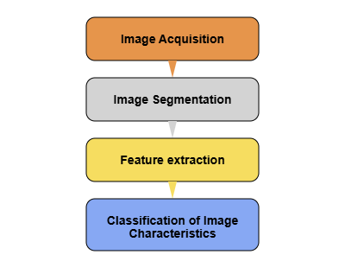

Fig. 2.1 Phases of plant disease detection system

2.2.1 Convolutional Neural Network
Machine learning includes convolutional neural networks, also known as convnets. It is a subset of the several artificial neural network models that are employed for diverse purposes and data sets. A CNN is a particular type of network design for deep learning algorithms that is utilized for tasks like image recognition and pixel data processing.Three layers make up a convolutional neural network: the convolutional layer, the pooling layer, and the fully connected layer .Using a filter, the convolutional layer scans the images one or more pixels at a time to create an activation map. The convolutional layer's data is stored more effectively by the pooling layer by reducing the amount of data it generates. Fully linked input layer. In order to predict the correct label, the first fully connected layer applies weights to the feature analysis inputs. In the end, the fully connected output layer provides the probability for each label [12].

Fig. 2.2 Convolution neural network

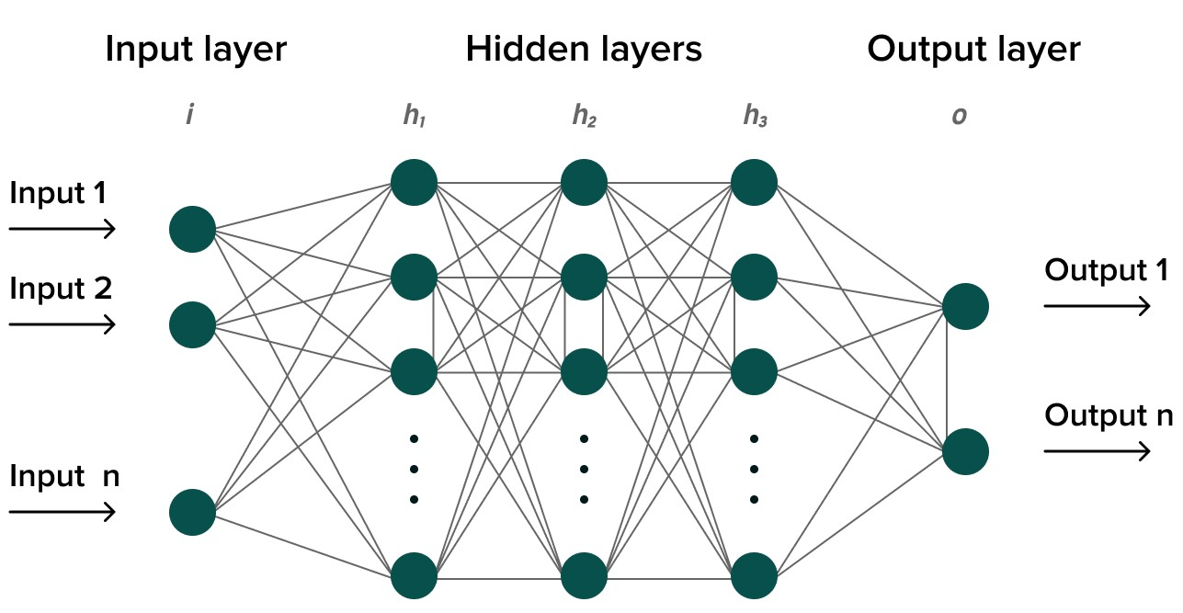
2.2.2 By Deep learning method with convolution neural network (CNN)

Farming is currently greatly aided by deep learning, computer vision, image processing, robots, and IoT technology. Because it provides high-quality photos, AI- based drone technology is particularly beneficial for farming because it makes it simpler to monitor, scan, and evaluate the crops. This technology helps to track the development of the crops. Farmers can also choose whether or not the crops are ready for harvest. There is no end to how one may characterize the uses of deep learning in agriculture.

Deep learning is a machine learning methodology that instructs computers to learn by doing what humans do naturally. Deep learning is a machine learning technique that teaches computers to learn by doing what humans do naturally. Deep learning has grown in popularity for a variety of reasons. It is experiencing previously unthinkable outcomes. In deep learning, a computer model is used to perform and also classify tasks directly from images, text, or sound. A large set of labelled data and multi-layered neural network architectures are used to train models.

2.2.3 K- Clustering methodology

It is an iterative process of assigning each data point to a group and gradually clustering data points based on similar features. The goal is to minimize the sum of the distances between the data points and the cluster centroid in order to determine which group each data point should belong to. We divide a data space into K clusters and assign each a mean value. The data points are assigned to the clusters with the highest mean value.

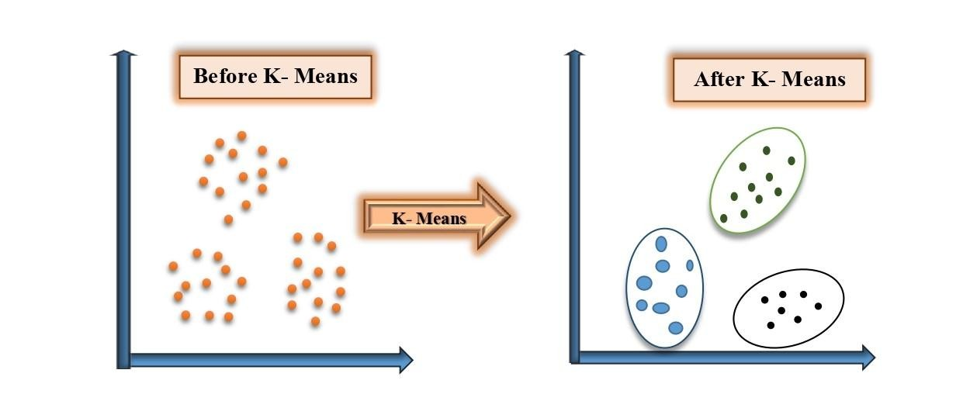

Fig. 2.3 K- Clustering Algorithm

Cluster analysis is the process of categorizing data into groups based on shared characteristics. Precision agriculture aims to optimize production by managing a small portion of the field. Clustering can be used in agriculture to extract data about soil moisture levels and crop-related climatic conditions such as temperature, humidity, and rainfall statistics [13, 14].

2.3 Comparison based on Existing Algorithms

Now we will take a look at different Agricultural disease detection methodology ideas implemented based on previous research articles.

H. Al-Hiaryet.al [15] The overall concept that serves as the framework for any vision related image classification algorithm is nearly identical. First, digital images are captured from the environment with a digital camera. The acquired images are then subjected to image-processing techniques in order to extract useful features required .

Piyush Chaudharyet.al [16] The images of leaf are all in JPEG format. These images are colour transformed from RGB to one of the colour spaces named YCbCr, HIS, and CIELAB. To remove unnecessary spots, the colour transformed images are passed through a median filter. In the final step, the Otsu threshold is applied to the RGB image, with the 'A' component of CIE LAB colour space, the 'H' component of HSI colour space, and the 'Cr' component of YCbCr colour space used to detect the disease spot. All three methods' disease spot segmented images are compared to determine the best method for disease spot detection.

P. Revathiet.al [17] This proposed work is based on image RGB feature ranging techniques used to identify diseases (using Ranging values), in which the captured images are first enhanced. Then, to obtain target regions, colour image segmentation is performed (disease spots). Following that, homogenization techniques such as the Sobel and Canny filters are used to identify the edges, and the extracted edge features are used in classification to identify the disease spots.

S. Arivazhaganet.al [18] The leaf images obtained are converted to HSI format. The co- occurrence matrix is used to derive co-occurrence features such as contrast, energy, local homogeneity, shade, and prominence. Plant diseases are detected using this set of co-occurrence features. There are leaf samples with various diseases such as early scorch, yellow spots, brown spots, late scorch, bacterial and fungal disease.

J. G. A. Barbedo et.al [19] A method for detecting and quantifying leaf symptoms using conventional colour digital images is presented. The method was designed to be completely automatic, remove the possibility of human error and shortening the time required to assess disease severity .This system can handle images with multiple leaves, which cuts down on processing time even more. When the symptoms and leaf veins have similar colour and shade characteristics, accurate results are possible. One restriction applies to the algorithm: the background must be as close to white or black as possible. Tests revealed that the method provided accurate estimates under a wide range of conditions, including variations in leaf size, shape, and colour, as well as symptoms and leaf veins. Extrinsic factors such as image capture issues and the use of extreme file compression ratios resulted in low rates of false positives and false negatives.

Mukesh Kumar Tripathiet.al [20] To identify and detect diseases on agricultural products, popular methods have used machine learning, image processing, and classification-based approaches. Various image processing methods, followed by various classification techniques, have been used in existing disease detection techniques. This paper provides overview of existing reported techniques for detecting agricultural product diseases.

Guan Wanget.al [21] Deep learning, the most recent advance in computer vision, appears promising for disease severity classification as it avoids laborious feature engineering and threshold-based segmentation.. A series of deep convolutional neural networks are trained to diagnose disease severity using images of apple black rot from the Plant Village database, described by botanists into four severity levels, as the ground truth. In this paper, the performance of surface meshes built from scratch and deep models refined by transfer learning are systematically evaluated. A deep VGG16 model trained with transfer learning is the best.

Trimi Neha Tete et.al [22] Two distinct segmentation techniques, such as thresholding and the K-means clustering algorithm, as well as a classification
technique, the Artificial neural network, are used (feed forward back propagation). First, digital images of plant leaves are captured in the field using a camera. This image is then pre- processed. The original image is then segmented and useful features extracted to identify the infected parts of the plant leaf are extracted using two different segmentation processes. Following that, the classification technique was carried out using the toolbox in the MATLAB software.

Ashwin Dhakal et.al[23] Deep Learning has emerged as one of the most accurate and paradigms for detecting plant disease. Infected crop leaves are collected and labeled according to the disease. Image processing is combined with pixel-by-pixel operations to improve image information. It is then followed by feature extraction, segmentation, and classification of captured leaf patterns in order to identify plant leaf diseases. Bacterial Spot,Yellow Leaf Curl Virus, Late Blight, and Healthy Leaf are the four classifier labels used. With 20 epochs, the extracted features are fitted into the neural network. Several artificial neural network architectures with the best performance and accuracy are implemented.

M. Akilaet.al [24] Using images of plant leaves, this methodology proposed a deep- learning-based approach to detecting leaf diseases in many different plants. Our goal is to identify and develop more appropriate deep learning methodologies for our task. As a result, we consider three major detector families: Faster Region-based Convolutional Neural Network (Faster R-CNN), Region-based Fully Convolutional Network (R- FCN), and Single Shot Multibox Detector (SSD), which was used in this study. The proposed system can effectively identify various types of diseases and can deal with complex scenarios from a plant's area.

Ke Lin et.al [25] Plant leaf disease regions were divided into segments using the K- means algorithm. Random forest and Gradient boosting decision trees, on the other hand, are supervised learning methods that can be used to solve classification and regression problems. These three techniques may thus be applied to categorise pixels in a picture in order to partition the affected area. The proposed method to these three segmentation techniques. However, when the compared to deep learning-based methods, these three methods have lower model complexity, implying that their representation ability is not as powerful as deep learning-based methods.

Dr. Pankaj Mohindru et.al [26] To segment the infected region and assign it to the appropriate classes, a colour-based segmentation model is defined. Experiments were conducted on sample images in relation with the time complexity and infected region area. Image process techniques can detect plant diseases. Image acquisition, image pre- processing, image segmentation, feature extraction, and classification are all steps in disease detection.

V Suresh et.al [27] The images of the leaves and compare it with the data sets. This data set consists of different plants in the image format. A part from detection users are directed to an e-commerce website where different with its rate and usage directions are displayed. This website can be efficiently use for comparing the MRP of different pesticide sand purchasing the required one for the detected diseases.

Emma Harte et.al [28] This image of the leaves and comparing it with the data sets. The data set consists of various plants in images format. A side from detection, users are directed to an e-commerce website where various pesticides, along with their rates and usage instructions, are displayed. This site can be effectively used to compare the MRPs of different pesticides and purchase the required one for the identified disease. Convolutional Neural Networks (CNNs) are considered advanced image recognition with the ability to provide fast and accurate diagnosis. The performance of a pretrained ResNet34 model in detecting crop disease is investigated in this paper. The developed model, which is deployed as a web application, is capable of distinguishing seven plant diseases from healthy leaf tissue.

V Suresh et.al [29] The image database is entirely the responsibility of the application system developer. It identifies plant leaf types and diseases using a convolutional neural network and algorithms. The K-means clustering algorithm divides objects or pixels into K classes based on a set of features. Classification is performed by reducing the sum of squares of distances between elements and their corresponding clusters.

Shoyeb Ahammad Rafi et.al [30] An autonomous robotic technology to assist farmers by detecting leaf disease (guava as an example) and measuring temperature and humidity. The initial goal was to implement a prototype and test its feasibility in assisting farmers in quickly identifying diseases. Two techniques have been designed into the prototype. The first is motion, and the second is analysis, which includes image processing as well as real-time data processing. In the motion section, the robot decides whether to turn left, right, or stop based on three distinct colour ranges. In the second part, the robot determines whether the leaf is healthy or disease.

Kavitha et.al [31] In smart agriculture, deep learning algorithms are used to monitor the temperature and water level of the crops. This article proposes an Artificial Neural Network (ANN) for smart irrigation systems.

Nishant Shelar et.al [32] The sophisticated CNN VGG19 has layers that have now been taught and a deep understanding of how a picture is described in terms of form, colour, and structure. The deep neural network VGG19 network with tough classification tasks that has been trained on millions of pictures.

Sachin D et.al [33] Detection of plant diseases is the first step in mitigating the decline in production and quantity of agricultural products. It requires significant manpower, plant disease expertise and long processing times. Therefore, image processing is used to detect plant diseases. Procedures used in the disease detection process include image
acquisition, image pre-processing, image segmentation, feature extraction, and classification. This essay discussed methods for diagnosing plant illnesses using images of their leaves. This investigation explored several segmentations of the plant's sick portions. This study also included the methods for feature extraction, classification, and classification of plant diseases. It is essential for the efficient production of crops to be able to consistently diagnose and classify plant diseases using image processing. This investigation explored several segmentations of the plant's sick portions. This study also included the methods for feature extraction, classification, and the classification of plant diseases. Plant diseases may be distinguished using SVMs, back propagation methods, self-organizing feature maps, and other ANN approaches. These methods allow us to precisely identify and classify various plant diseases using image processing.

M. Malathi et.al [34] They carried out a paper survey on plant leaf disease identification using image processing technologies. Crop disease drastically reduces agricultural output in terms of both quantity and quality. It might be difficult for farmers to detect illness symptoms with the naked eye. Particularly large farms employ crop protection computerized image processing algorithms that may utilize leaf colour information to identify diseased leaves. Depending on the application, many image processing techniques have been created to address problems through pattern recognition and specific automatic classification tools.

Heeb Al Bashish et.al [35] In this paper, an image processing-based technique for identifying leaf and stem disease is proposed. In this programme, five plant diseases— early scorch, cottony mould, ashen mould, late scorch, and tiny whiteness—are being evaluated. Image-based tactics are offered. The recommended approach starts by segmenting the available pictures using the K-Means approach. The segmented pictures are then sent into a neural network that has already been trained.

Nivedithaet.al [36] In this study, leaf diseases were found using the threshold approach. The proposed method divides plant leaves into classes of infected and non-infected leaves and includes the following steps: 1) using k-means clustering to detect the infected object using thecolour co-occurrence approach for texture analysis to obtain the feature set of the infected items.
Amit Yerpude et.al [37] This piece provides Image segmentation is crucial in the field of image processing since it is widely used in the agriculture industry to identify plant ailments by classifying the various diseases. Plant diseases are categorized using the categorization method and numerous physical characteristics. To categorize, a variety of classifiers are utilized, such as SVM (Support Vector Machine), K-nearest neighbour classifiers, artificial neural networks, fuzzy logic, etc.

In article [38] a number of procedures are described for identifying diseased plant leaves, including the collection of RGB photographs. Converting the provided image's RGB to HSI format. The green pixels were masked and removed. A genetic algorithm was employed to classify the sickness after textural features were obtained using the colour-co-occurrence technique.

Sanjay B. Dhaygude et.al [39] the principal causes of most plant diseases are bacteria, fungus, and viruses. The most common way to identify fungi is by their morphology, specifically their reproductive organs. It is believed that bacteria are more fundamental and have simpler life cycles than fungus. The death of live plants is sometimes the only thing for which the word "disease" is used. The four main phases of the established processing plan are listed below. 1) Since HSI is used for colour description and RGB is utilized for colour generation, the RGB input image is first converted to HSI using a colour transformation structure. Next, a predetermined threshold value is used to mask and remove green pixels. The evaluation of disease activity on plant leaves is the final step.

Singh et.al [40] In this work, plant leaf diseases are automatically identified and categorized using an image segmentation technique. It also completes an examination of several disease classification methods that may be employed to recognise plant leaf diseases. Segmenting the photos is a crucial stage in the process of diagnosing illness in plant leaves, and it is done using a genetic algorithm. Ranjeet Kaur et.al [41] In this approach, technology improvements that help farming become more productive enable automated diagnosis of illness and pathological components present in plant leaf photos as well as in agricultural crop production. Although SVM (Support Vector Machine) already exists, the initial disadvantage of the neural network .
Creation of an entirely new method for improving accuracy using KNN. Throughout this analytical endeavor, they will concentrate on enhancing plant disease prediction methods and offer a completely unique solution for the detection rule.

Smita Naikwadi et.al [42] Complex photo segmentation techniques are utilized to identify leaf disease. Early detection of leaf disease is essential to maintaining the natural cycle. In order to help the classifier make a decision, the research examines system models that examine the supplied image and isolate the ill area. The higher degree of segmentation accuracy is supposedly satisfied by colour-based methods (such the green plane) and Ostu's algorithm. The experimental results led the system designer to conclude that the output of the module is adequate.
Jayme Garcia et.al [43] The main topic of discussion is how to discover, classify, and quantify plant diseases using visible-spectrum pictures that have been digitally processed. Despite the fact that the disease's symptoms can manifest in any part of the plant, only techniques that focus on the most evident symptoms in leaves and stems were taken into account. Detection, severity measurement, and classification are the three divisions into which the selected ideas are divided. Each of these classes is further divided in accordance with the primary technological solution employed in the approach. This paper presents a clear and comprehensible overview of this important area of research, which is expected to be useful for researchers researching both vegetable pathology and pattern recognition.

SujeetVarshneyet.al [44] have offered a succinct study of the classification accuracy of machine learning classifiers for identifying leaf diseases. Although each system's reaction differs based on the dataset, modern image processing employs a range of categorization approaches. The mentioned work shows the classifier accuracy and briefly examines each independent leaf dataset's individual classifier response. The accuracy of the classifier may fluctuate, but, as the data set changes, it is eventually selected.

The most important image processing challenge is the identification and evaluation of illness. This provides an overview of several approaches for detecting plant leaf illnesses using image processing techniques and also represents a strategy used by researchers to identify plant leaf diseases. An overview of the many strategies employed for recognition and analysis. The most advantageous approaches out of all these various ones will be studied. But despite the greatest advantages, each strategy has certain drawbacks. Although many techniques have been created, there is currently no universal technique or agreed-upon approach that is suitable for the identification and evaluation of any kind of disease. The disadvantage of using different procedures can be avoided by fusing different methodologies. The paper
reviews and analyses a few techniques that have been employed to identify plant diseases. Because symptoms of plant illness are invisible to the human eye. Growing enough crops to feed such a big population is essential since food is a basic human need and the world's population is growing at an alarming rate. Since it is hard to keep an eye on a field constantly, certain automated techniques must be used. One such technique is image processing, which may be used to identify plant diseases and has a complex methodology. The colour information contained in the leaves can be used to identify damaged leaves using various image processing techniques. Alternative classification techniques include nearest neighbour classifier, probabilistic neural network, genetic algorithm, support vector machine, and principal component analysis, Artificial Neural Network, Fuzzy Logic, etc. It has always been difficult to select a classification technique since the quality of the outcomes might change based on the input data. Diverse studies have offered their approach or study on how digital image processing techniques may be utilized to identify leaf diseases in their early stages and apply various ways to protect the plant or leaf from potential harm. The most important image processing challenge is the identification and evaluation of disease. Therefore, this chapter describes the survey done on several methods for detecting plant leaf illnesses using image processing techniques and also denotes a strategy used by researchers to identify plant leaf diseases. But despite the greatest advantages, each strategy has certain drawbacks. Although many techniques have been created, there is currently no universal technique or agreed-upon approach that is suitable for the identification and evaluation of any kind of disease. The disadvantage of using different procedures can be avoided by fusing different methodologies.

CHAPTER- 3

“DETECTION AND CLASSIFICATION OF AGRICULTURAL LEAF DISEASES USING HISTOGRAM TECHNIQUE”

3.1 Introduction

Productivity in agriculture contributes significantly to the economy. The factors contributing to the significance of plant disease detection in the agricultural industry, as plant diseases are frequently present. The quality, quantity, or productivity of the corresponding crops are adversely affected, and plants suffer serious consequences if necessary steps are not taken in this area. Rose plants are afflicted by the hazardous illness known as little leaf disease.

The advantage of using an automatic method for plant disease detection is that it reduces the aggregate of personnel needed to monitor large crop farms and may spot disease signals when they first appear on plant leaves.

This chapter presents a proposed methodology adopted to detect the diseases in plant leaves by using an image segmentation method for the automatic detection and classification of plant leaf diseases. It also provides an overview of various disease classification techniques that can be used to identify plant leaf diseases.

Image segmentation, an essential phase in the plant leaf disease diagnostic process, is done using histogram equalization and other filters [91].

Plant ailments are now a worry since they could significantly affect the quality and output of agricultural products. In India, 70% of people are employed in agriculture. A vast range of fruit and vegetable crops are available to farmers. However, a high level of technical skill is required to grow these crops with the best yield and productivity. Utilizing technology might make it better.

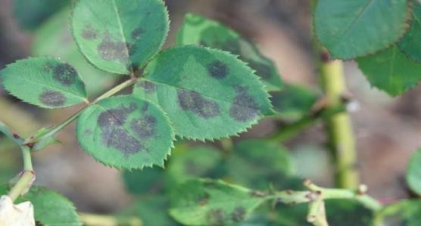

Fig. 3.1 Image of infected leaf affected by the pathogens

Managing perennial fruit crops requires ongoing monitoring, especially for the prevention and treatment of illnesses that can significantly reduce yield and, as a result, the postharvest life.

The automatic classification of leaf diseases has been achieved by scientists using high- resolution multispectral and stereo images. The leaves of sugar beet are used to evaluate their approach. Sugar beetroot leaves could be harmed by a number of ailments, such as rust and powdery mildew. A pathogen or an agent that has the potential to cause illness is what causes disease. On a plant's leaves or stems, diseases and pests are frequently visible. For crops to grow effectively, it is essential to know how to identify plants, leaves, and stems as well as understand pests and diseases and their symptoms. It has been found that each year, diseases cause major agricultural losses.

Disease management is a challenging endeavour. Plant disease typically affects the leaves or stems. The accurate quantification of these visually perceived diseases, pests, and traits has not yet examined due to the complexity of visual patterns. There is consequently an increasing demand for more accurate and sophisticated visual pattern comprehension. A single experiment in biological study could result in hundreds of images. The vast majority of these tasks are carried out manually or with the aid of different software packages. It takes a lot of work, but it also has two major issues: lengthy processing times and subjectivism caused by numerous people [92, 93,103].

3.1.1 Biology point of view

Much work has been done in the field of leaf recognition to extract generic features or recognize several item groups. When recognizing certain domains, the system performs better since it takes into consideration the special traits that fall under this group. Despite the project high level of technicality, working with leaves has a biological undertone. It is necessary to acquire and understand very fundamental information about leaves from the viewpoint of how scientists

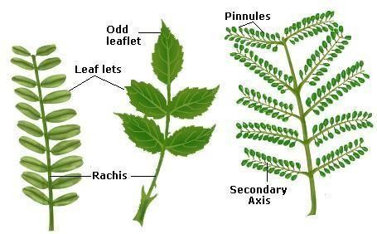

Fig- 3.2 Leaf features

themselves recognize and contribute to leaves. Biologists also stress the significance of leaves, which can range greatly in size, shape, and disposition and serve as a useful tool for distinguishing related blooms [92, 93, and 94]. As seen in Fig.6.2 the arrangement of the leaves on the stem might be alternating, opposing, or whorled. There are several forms of leaf enervations, including dichotomist, parallel, palmate, and pinnate nerves. The following details are described in data.

3.2 Proposed methodology

Digital cameras are used to capture images of diverse leaves. Additional picture pre- processing methods are used following the acquisition of those images.

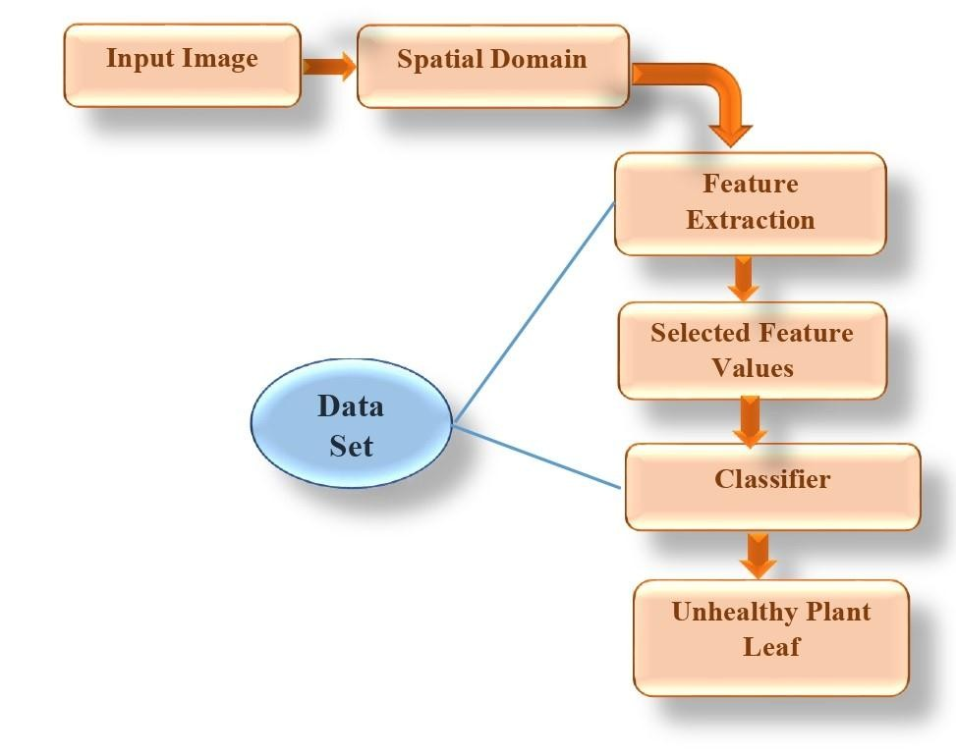

Fig. 3.3 Block diagram of proposed approach

3.2.1 Colour transformation structure

A representation in HIS colour space is initially created using the RGB pictures of the leaves. The basic goal of the colour space is to make it simpler to express colours in a consistent, well- known way. The HSI (hue, saturation, intensity) model is a well- known colour model since it is based on how people perceive colour. A colour's hue indicates the colour that an observer would recognize as being dominant. While intensity refers to the width of the light beam, saturation refers to the amount of white light that is added to a colour. It is easy to switch between different colour spaces. After the transformation process, a closer evaluation of the H component is taken into account. S and I components are left out because they don't add anything.

3.2.2 Segmentation

The affected leaf section is removed using the procedures mentioned above. The contaminated area is then divided into many patches of comparable size. The patch's size was selected in such that the important data would not be lost. This method uses a patch size of 32 by 32 pixels. Extraction of the relevant portions is the following step. Not every part includes a substantial quantity of information. Therefore, for further analysis, the patches with more than 50% of the information are taken into consideration.

3.2.3 Colour co-occurrence method

The colour co-occurrence texture analysis method was developed using the SGDM. The gray- level co-occurrence methodology is a statistical method of characterizing form by statistically sampling how specific things happen. Gray levels do exist in relation to other gray levels. These matrices determine the possibility that every pixel, given that it has a second distinct level of gray, will be situated in relation to every other pixel at a particular distance and orientation. SGDMs are expressed using the function P (i, j, d), where I denote the gray level of the position (x, y) and j denotes the gray level of the pixel at a distance d from the location (x, y) at an orientation angle of. The H image produces SGDMs.

3.2.4 Filters

Each image that is taken really has noise in it. The visual definition suffers from numerous types of noise and interference. Additionally, noise causes the image to become blurry. The poor state was completely buried. It makes analysis very challenging. To enhance visual quality, humans must thus minimize undesirable noise. The fundamental filtering methods are applied to the noise reduction of digital images. It consists of bilateral filtering, Gaussian filtering, mean filtering, and median filtering. De-Noising Mean Filter is a linear filter algorithm. In other words, a template is made larger for the target pixel, and the average pixel value is then used in place of the original pixel value.

3.2.5 Histogram equalization

A histogram is a precise graphical representation of the distribution of numerical data. It was first introduced as an estimate of the distribution of a continuous variable (quantitative variable) by Karl Pearson. It has a bar-graph appearance. The initial stage in producing a histogram is binding the range of data, or segmenting it into intervals. The number of values that fit into each interval should then be counted. The bins are frequently described as a collection of distinct, non-overlapping intervals. The bins (intervals) must be placed close to one another and are typically, though not always, the same size. In the case of equal-sized bins, a rectangle is constructed over it with a height proportional to the number of instances in each bin. Another option is to normalize a histogram to display relative frequencies. Then, with the heights adding up to 1, the proportion of examples that fall into each of the numerous categories is displayed. Even if bins don't always have to be the same width, the created rectangle is defined to have an area proportional to the frequency of instances in the bin. As a result, rather than using frequency as the vertical axis, the frequency density, or the number of cases per unit of the variable on the horizontal axis, is used. Here are a few samples of Census Bureau data that demonstrate changing bin width. Since adjacent boxes leave no space between them, the rectangles of a histogram come into contact with each other to demonstrate that the original variable is continuous. Histograms are widely used for density estimation, or computing the probability density function of the underlying variable, as they give a general understanding of the density of the underlying data distribution. The area of probability density histograms is always normalized to 1. If the intervals on the x-axis are all 1 length, then the histogram and relative frequency plot are identical. A histogram is a straightforward kernel density estimate that uses a kernel to smooth frequencies over the bins. This leads to a smoother probability density function that, in general, more accurately depicts the distribution of the underlying variable. It is possible to plot the density estimate as an alternative to the histogram, which is commonly shown as a curve rather than a list of boxes. A simple alternative that yields a smooth curve estimate of the density without the requirement for kernels is the average shifted a histogram. The histogram is one of the seven essential tools of quality control. Histograms and bar charts can occasionally be inaccurate. A histogram, where the bins represent ranges of data, is used for continuous data, while a bar chart is used to illustrate categorical variables. Some experts suggest putting spaces between the rectangles in bar charts to make the contrast between the two more obvious. For our method, a variety of plant leaves from various plant species have been gathered but only rose and tomato leaves have been considered. The leaf photos that were captured are filtered and transformed into histogram format. Different textural characteristics, including mean, smoothness, contrast, etc. These properties allow for the detection of plant diseases. The Minimum Distance Criterion is initially used to classify. After analysis, different leaf photos are looked at and whether the leaf is healthy or unhealthy is determined.

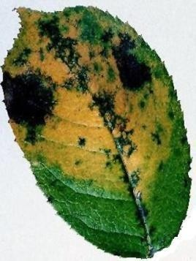
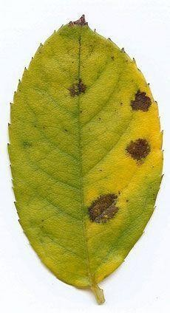

Fig.6.4 Bacterial diseases in Rose Leaf (Unhealthy leaf)

CHAPTER-4
EXPERIMENTAL RESULT AND DISCUSSION

4.1 Implementation Details

Identifying the disease at its primitive stage and suggesting that pesticides, names and quantity of fungicides are very emerging needs of modern agriculture. In traditional agriculture, diseases are only identified by real-time observation, but today the daily area covered by any type of fruit field is increasing, so it is not possible to identify diseases by the only real-time observation.

Nowadays most of the people doing service also take an interest in different types of flower farming but they don’t have knowledge of conventional agricultural methodology. They need a special type of help and support system to become successful in agriculture. If these farmers will use the proposed system, they can start spraying applications remotely if disease probability is severe. This approach can also be developed using normal techniques like JAVA, but using MATLAB gives the efficient and effective result. As the main focus of this application is user-friendly, this application is designed in such a way that it supports the multilingual concept. This application is helpful for farmers and laboratories where they can easily protect their crops and there will be an increase in growth production growth.

By using the proposed system they can detect and prevent the disease remotely from any location in the world. Due to its robust Image Processing Toolbox, MATLAB is the main topic of this chapter and how it is employed in the field of digital image processing. A wide range of features and tools created especially for picture alteration, analysis, and improvement are provided by this toolkit. Users may import and export photos, conduct image filtering and convolution, employ several image enhancing algorithms, and segment images into useful parts using MATLAB. Additionally, MATLAB offers capabilities for measurements, picture registration, analysis, and feature extraction as well as morphological procedures. It also provides versatile choices for picture visualization and presentation. A common choice for academics, engineers, and professionals working in fields including computer vision, medical
imaging, remote sensing, and multimedia is MATLAB due to its strengths in digital image processing. MATLAB is a crucial tool for successfully completing challenging image processing jobs due to its broad capability, simplicity of use, and integration skills. There are several uses for MATLAB, including Plant photos that may be

analysed to spot illness or anomalies using digital image processing techniques. Using the suggested method, we will be able to identify and prevent the disease from anywhere in the world. This chapter provided the implementation details and result analysis of the proposed methodology presented in the previous chapter. This chapter performance evaluation parameters as well as result analysis is discussed for result evaluation. Simulation is performed by hardware as well as software [94].

4.2 Performance parameters

4.2.1 Software Implementation detail MATLAB

For numerical computing, data analysis, visualization, and algorithm creation, MATLAB (short for matrix laboratory) is a high-level programming language and development environment that is extensively used in the scientific and engineering areas. It was first created by Math Works and made public in 1984.These toolboxes cover a wide range of topics, including machine learning, statistics, control systems, optimisation, signal processing, and more. Users can easily complete intricate calculations and analyses thanks to the functions and algorithms contained in each toolbox that are designed for particular tasks within that domain. One needs an effective understanding of MATLAB's syntax, functions, and toolboxes in order to utilize it successfully. Practice, online resources, official documentation, and lessons offered by MathWorks, the firm that created MATLAB, are all ways to learn this. Additionally, MATLAB enables users to construct interactive applications and interfaces for their MATLAB code by supporting the development of graphical user interfaces (GUIs). Overall, MATLAB offers a complete environment for computational science and engineering, making it a flexible and popular tool in many industries [95,102].

4.2.1.1 The main attributes of MATLAB are

MATLAB is effective for working with numerical data and doing calculation
involving linear algebra because it provides extensive support for matrices and
Various mathematical and scientific operations are available, including trigonometric, statistical, interpolation, curve fitting, numerical integration, and the solution of differential equations.

• Visualization: Users may construct 2D and 3D plots, surface plots, histograms, animations, and bespoke visualizations using MATLAB’s robust plotting and visualization features.

• Application development: Using its in-built capabilities, MATLAB makes it possible to create apps and user interfaces. These programmes can be used independently or in conjunction with other types of software and computer languages.

•Simulink integration: Simulink integration enables users to model, simulate, and analyse dynamic systems, including control systems, signal processing systems, and more. Simulink is a graphical programming environment that is strongly connected with MATLAB. A digital image processing system is used by MATLAB. Due to its extensive Image Processing Toolbox, MATLAB is a well-liked option for processing digital images. Here are some applications for MATLAB in a system for digital image processing:

MATLAB has routines to read and write a number of image formats, including JPEG, PNG, TIFF, and BMP. You may export produced photos to external apps or enter images into MATLAB for processing.

Sharpening, noise reduction, histogram equalization, contrast correction, and other functions for improving images are all available in MATLAB. These features aid in enhancing details and image quality.

• Image Filtering and Convolution: MATLAB provides functions for filtering and convolution operations, allowing you to apply various filters to images. These operations can be used for tasks like blurring, edge detection, and smoothing.

• Image Segmentation: MATLAB includes functions for image segmentation, which involves dividing an image into meaningful regions. Techniques such as thresholding, region-growing, and clustering can be used to separate objects or

extract specific features from images.

• Feature Extraction: MATLAB offers functions for extracting features from images, such as shape descriptors, texture features, and colour features. These features can be used for object recognition, classification, and image retrieval tasks.

• Morphological Operations: For morphological operations including dilatation, erosion, opening, and closing, MATLAB offers functions. These techniques are helpful for tasks like eliminating noise from photos, filling in blank spaces, and extracting certain structures.

• Image registration: which entails aligning several pictures obtained from various angles or at various times, is supported by MATLAB. Picture fusion, super- resolution, and motion correction are a few examples of jobs that might benefit from picture registration.

• Measurements and Image Analysis: MATLAB provides tools for measuring and image analysis, including methods for determining pixel intensities, object areas, and centroids. These measures can be applied to object characterization and quantitative analysis.

• Image Display and Visualisation: There are several functions in MATLAB for image
display and visualization. Plots of different kinds, graphic overlays on photos.

• Application Development: MATLAB enables you to create GUIs and program for processing digital images. Custom interfaces, image processing techniques, standalone executable deployment, and application integration with other software systems are all options.

Digital image processing methods may be used to examine plant photos and spot symptoms of illnesses or anomalies since MATLAB has a wide range of applications.

4.3 Result analysis

Disease management is a challenging task. Mostly diseases are seen on the leaves or stems of the plant. Precise quantification of these visually observed diseases, pests, traits has not studied yet because of the complexity of visual patterns. Hence there has been increasing demand for more specific and sophisticated image pattern understanding. In the following proposed method we have taken the samples of some plant leaves for example rose and tomato by using histogram equalization method in spatial domain we are going to find from which part the leaves are getting rotten or to detect healthy and unhealthy leaf of plant and as histogram smoothing is a spatial domain method that produces an output image with a uniform distribution of pixel intensities, which means that the histogram of the output image is systematically smoothed and stretched. This approach usually works for the image enhancement paradigm due to its simplicity and relatively better than other traditional methods. With the proposed method, Histogram smoothing techniques are used, which is a spatial domain method that produces an output image with a uniform distribution of pixel intensities, which means that the histogram of the output image is systematically smoothed and expanded. This approach usually works for the image enhancement paradigm due to its simplicity and relatively better than other traditional methods. Using the histogram of the input image, we obtain the probability density function (PDF) and the cumulative density function (CDF). Apply these two PDF and CDF functions to replace the grayscales of the input image with the new grayscales, then we create the processed image and the histogram of the resulting image. And when we contrast the histogram of the input image with the histogram of the processed image, we find that the intensity of the gray level systematically stretches and decreases. Therefore, we get that the histogram of the output image is systematically distributed. However, this provides excessive enhancement of images above the true gray range. When approaching histogram alignment, the average brightness of the processed image is always the average gray level without worrying about the input average.

4.4 Outputs

The standard benchmark pictures with intensity levels ranging from 0-255 are used to implement and evaluate the image of the suggested methods (Rose and Tomato). The thesis uses the following example photos as its dataset.

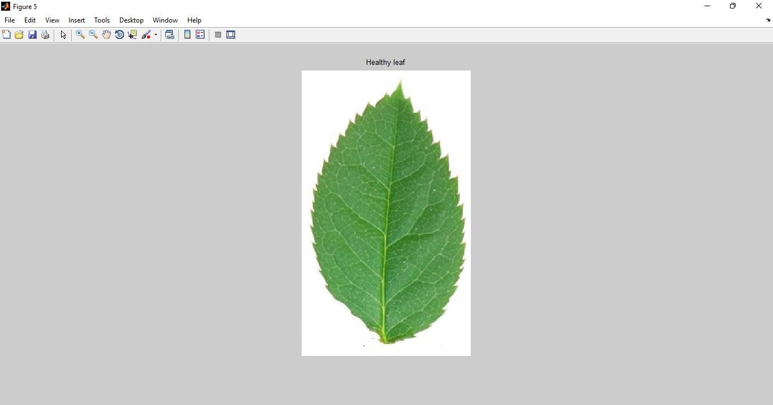

Fig. - 4.1 Shows the Rose healthy used in the experiment (Sample 1)

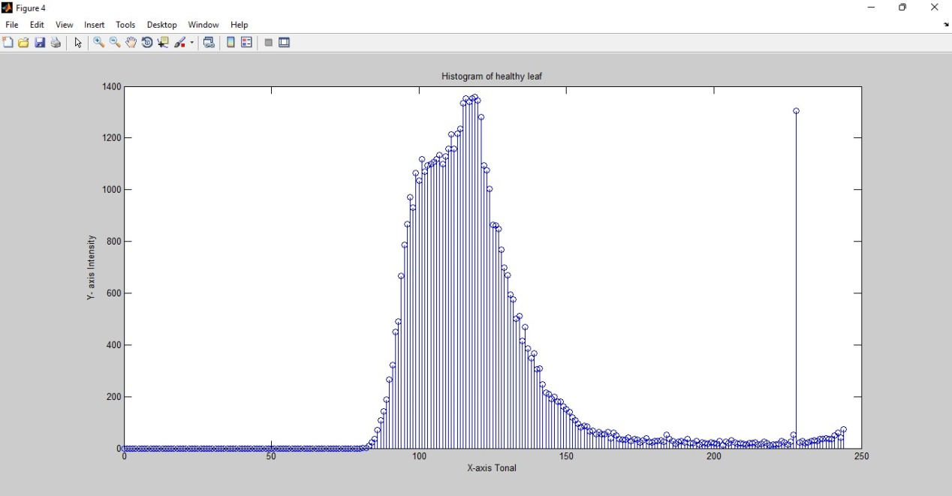

Fig. -4.2 Shows the Histogram of Rose healthy leaf in which Y-Axis represents the intensity whereas X-Axis represents the tonal (Sample-1)

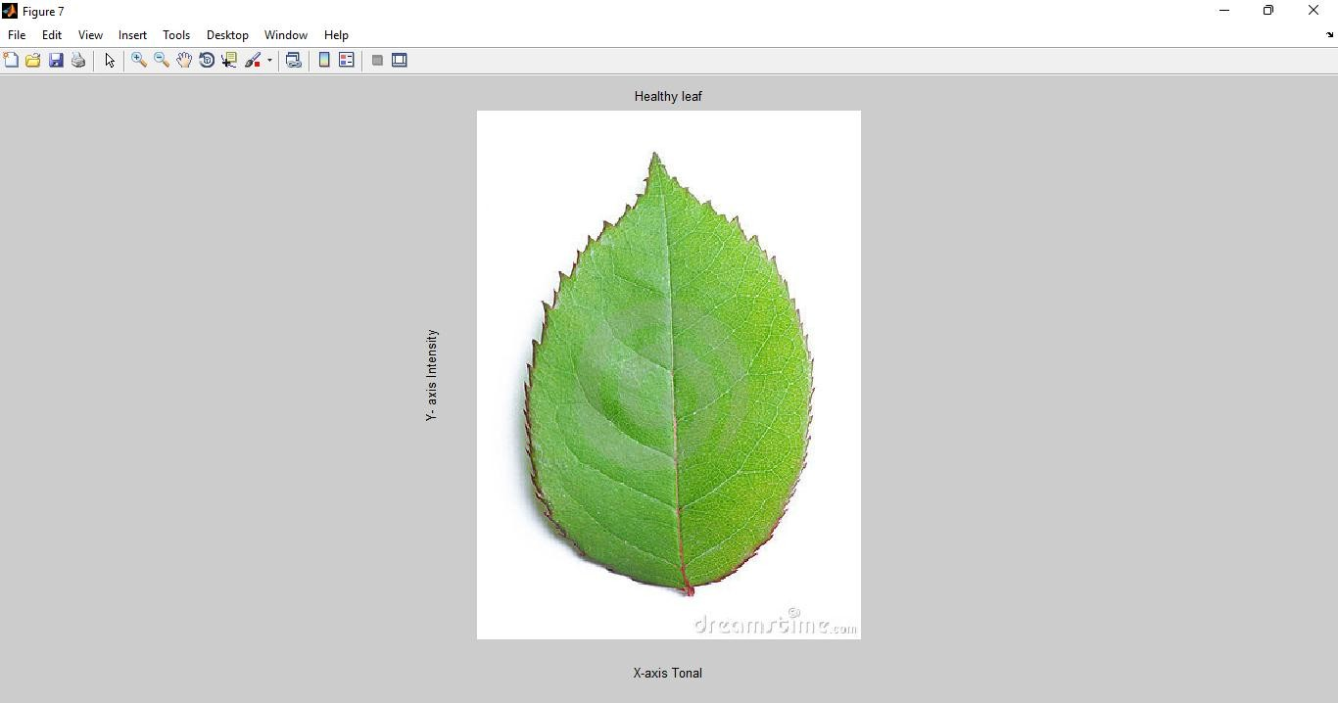

Fig. - 4.3 Shows the rose healthy used in the experiment (Sample 2)

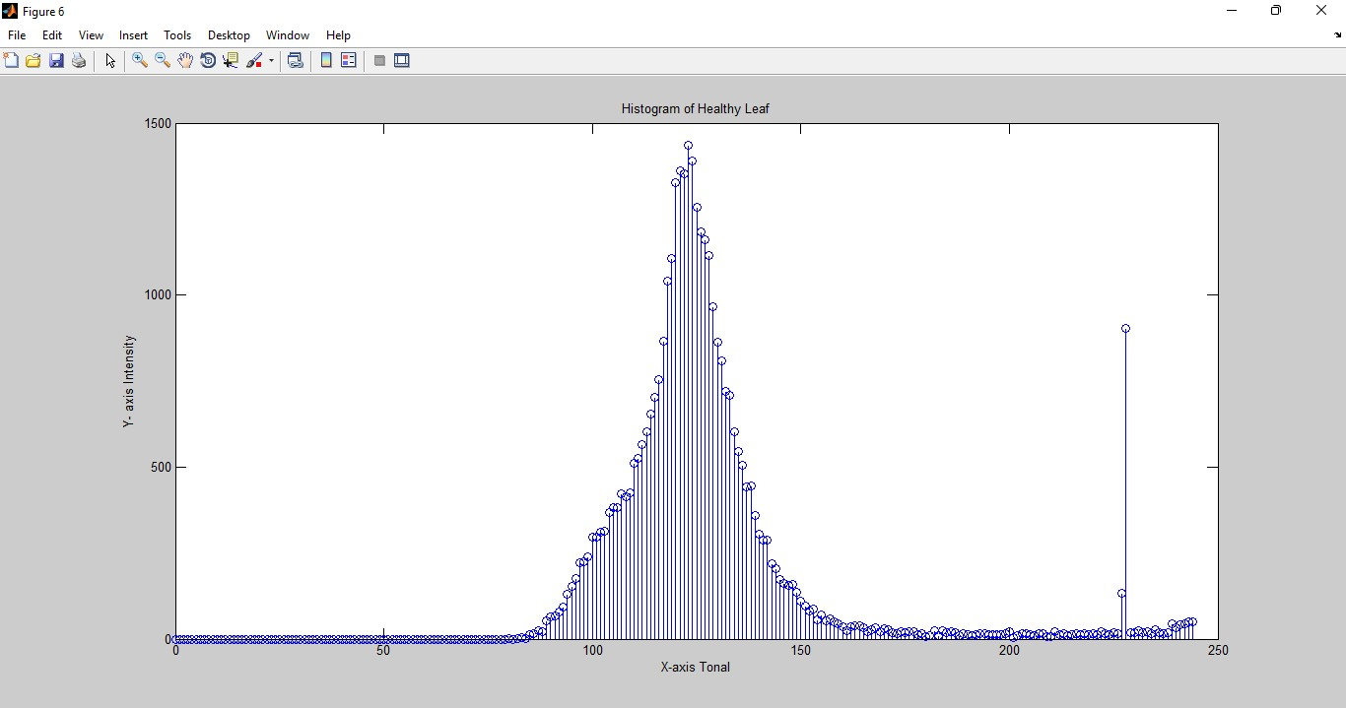

Fig. -4.4 Shows the Histogram of Rose healthy leaf in which Y-Axis represents the intensity whereas X-Axis represents the tonal (Sample-2)

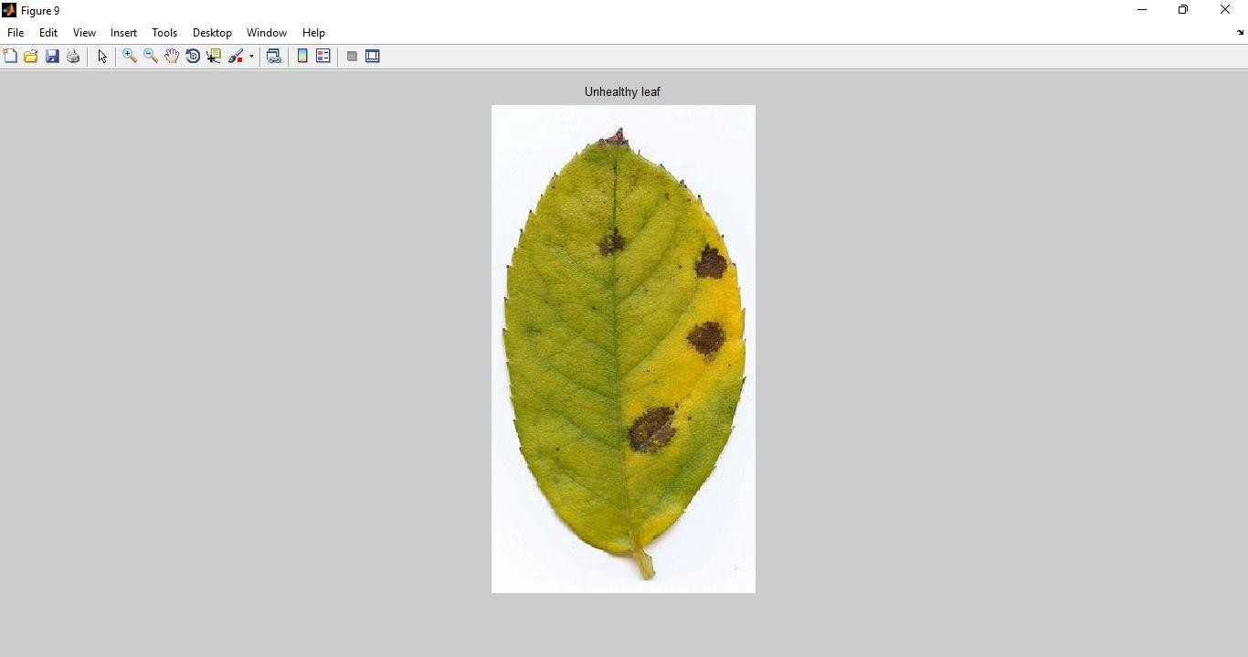

Fig. -4.5 Shows the Unhealthy Rose leaf used in the experiment (of (Sample 1)

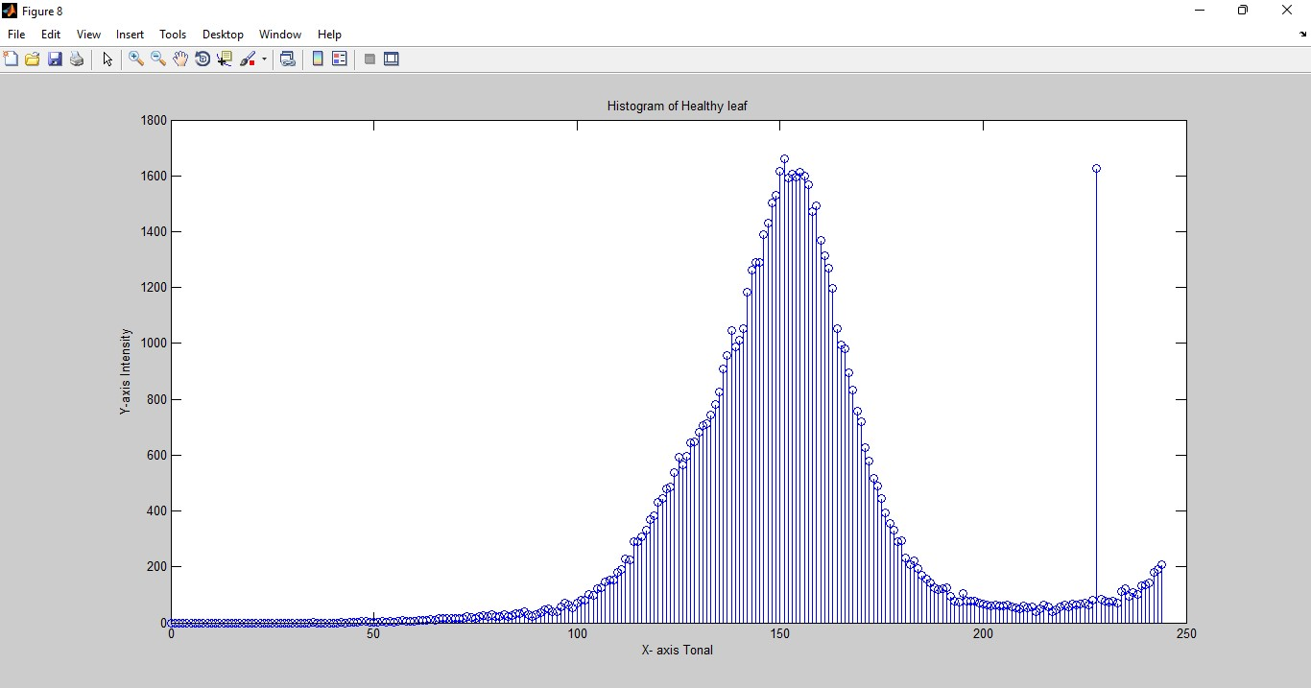

Fig. –4.6 Shows the Histogram of Unhealthy Rose leaf in which Y-Axis represents intensity whereas X-Axis shows represents the tonal (of sample-1)

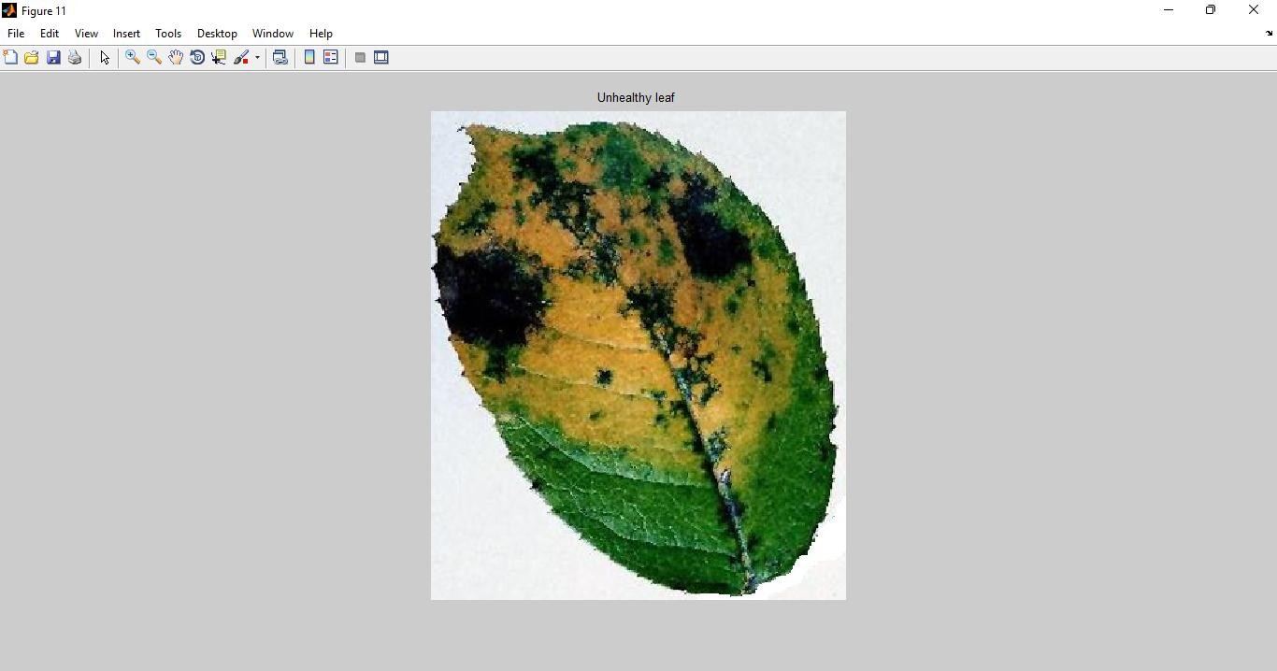

Fig. -4.7 Shows the Rose Unhealthy used in the experiment (of Sample 2)

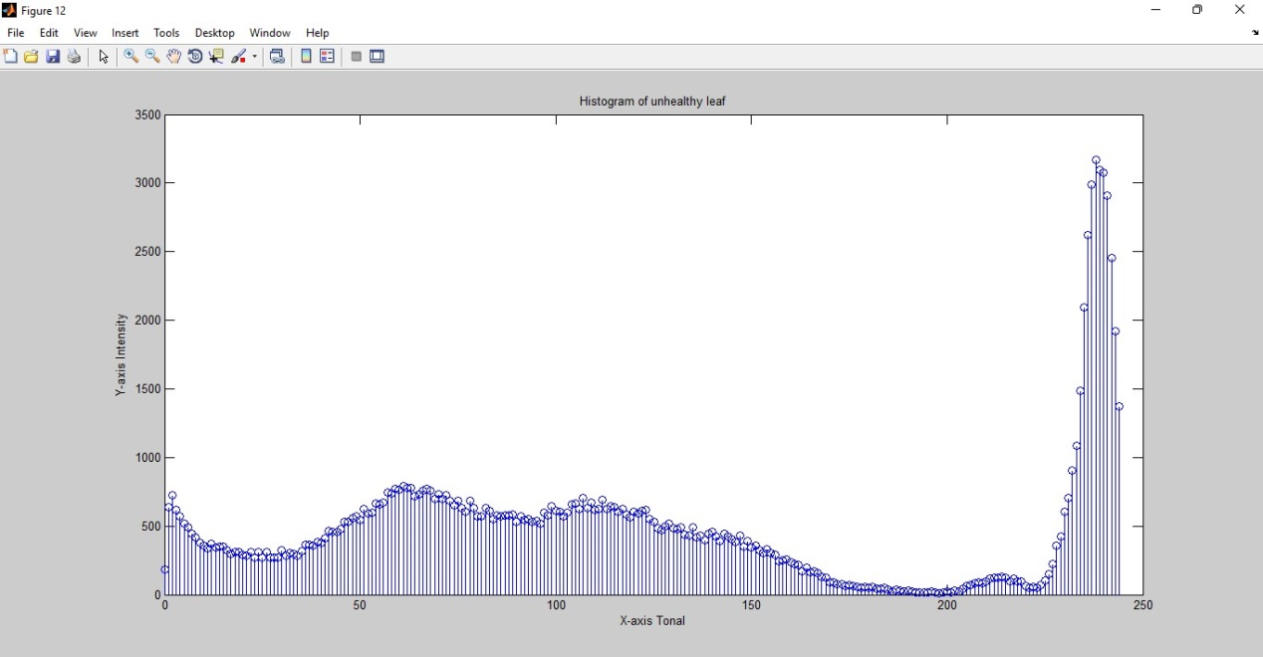

Fig. -4.8 Shows the Histogram of Unhealthy Rose leaf in which Y-Axis represents intensity whereas X-Axis shows represents the tonal (of sample-2)

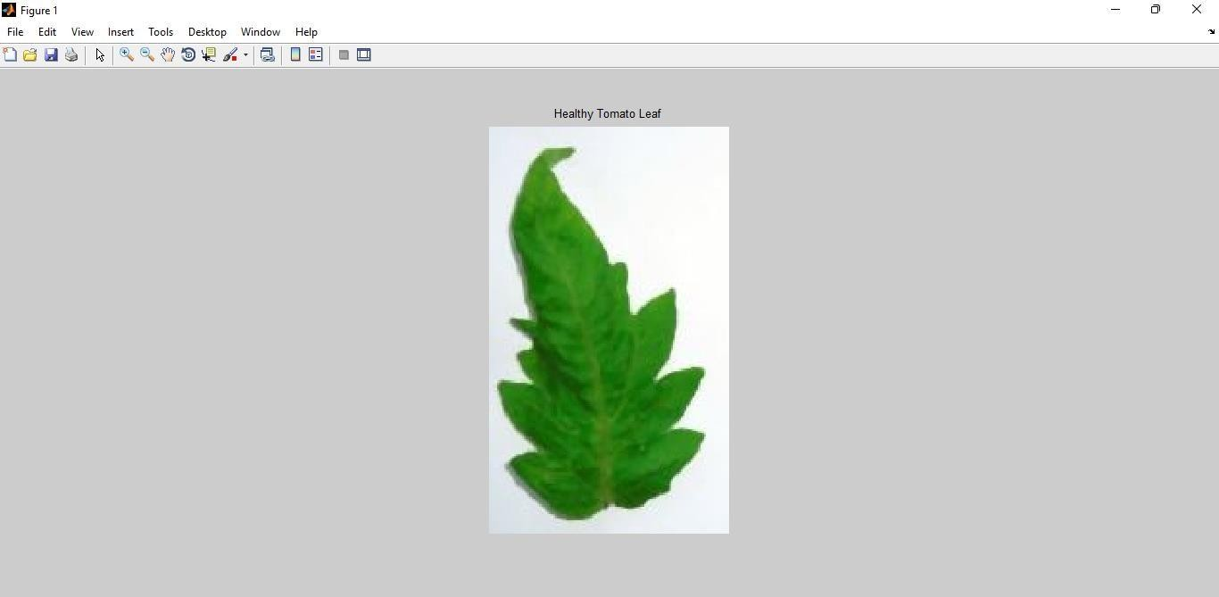

Fig. - 4.9 Shows the Tomato healthy used in the experiment (Sample 1)

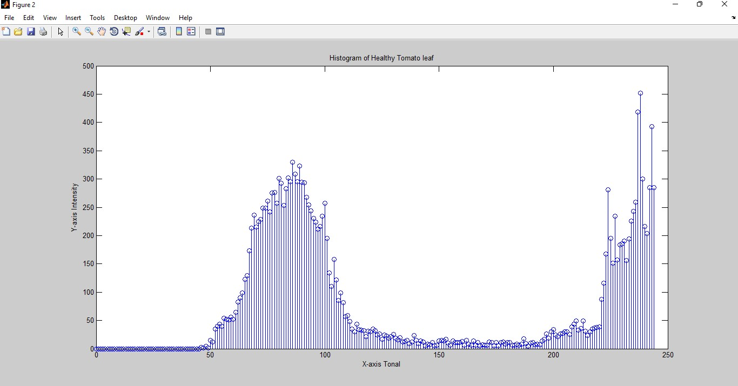

Fig. - 4.10 Shows the Histogram of Tomato healthy leaf in which Y-Axis represents the intensity whereas X-Axis represents the tonal (Sample-1)

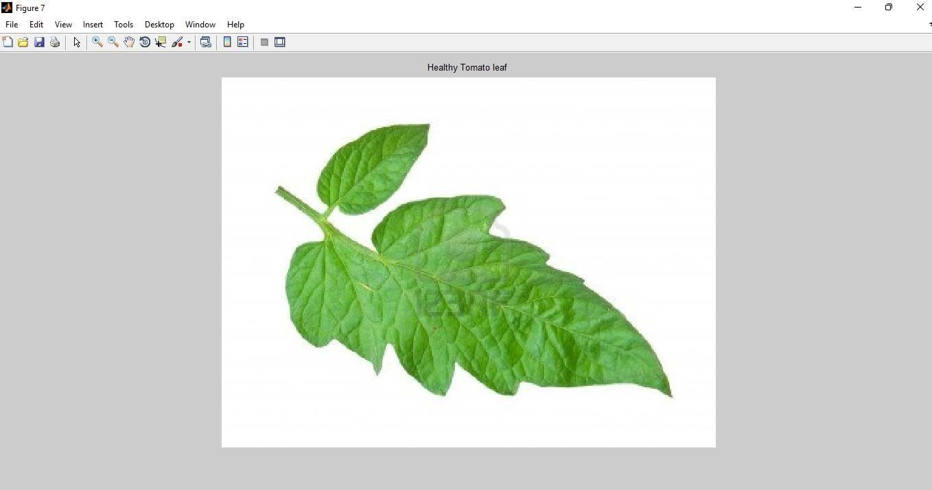

Fig.-4.11 Shows the Tomato healthy used in the experiment (Sample 2)

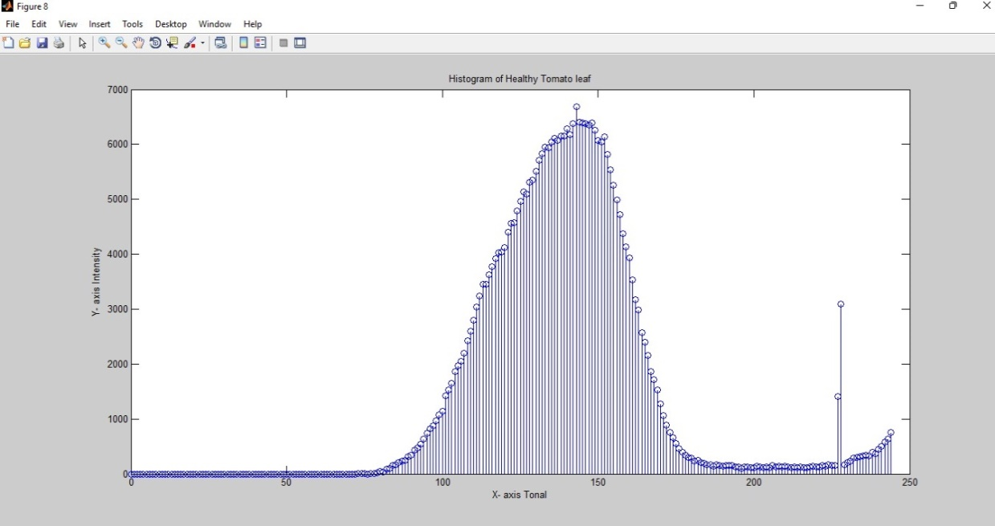

Fig. - 4.12 Shows the Histogram of Tomato healthy leaf in which Y- Axis represents the intensity whereas X-Axis represents the tonal (Sample-2)

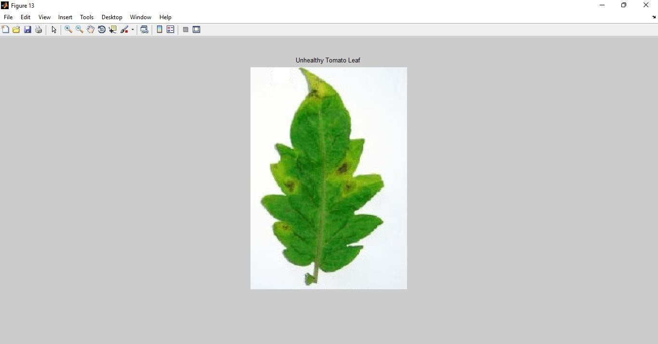

Fig. - 4.13 Shows the Unhealthy Tomato leaf used in the experiment of
(Sample 1)

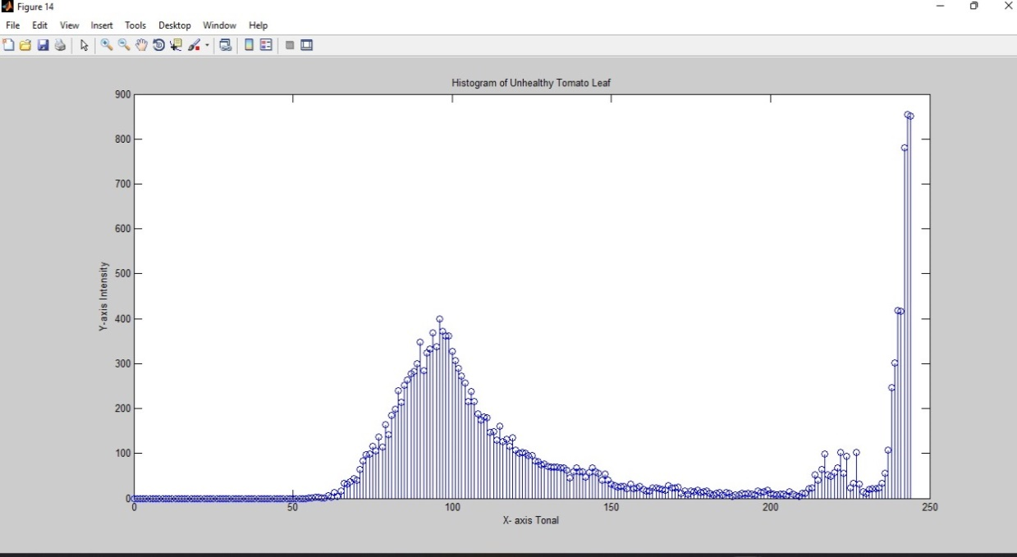

Fig. - 4.14 Shows the Histogram of Unhealthy Tomato leaf in which Y-Axis represents intensity whereas X-Axis shows represents the tonal (of sample-1)

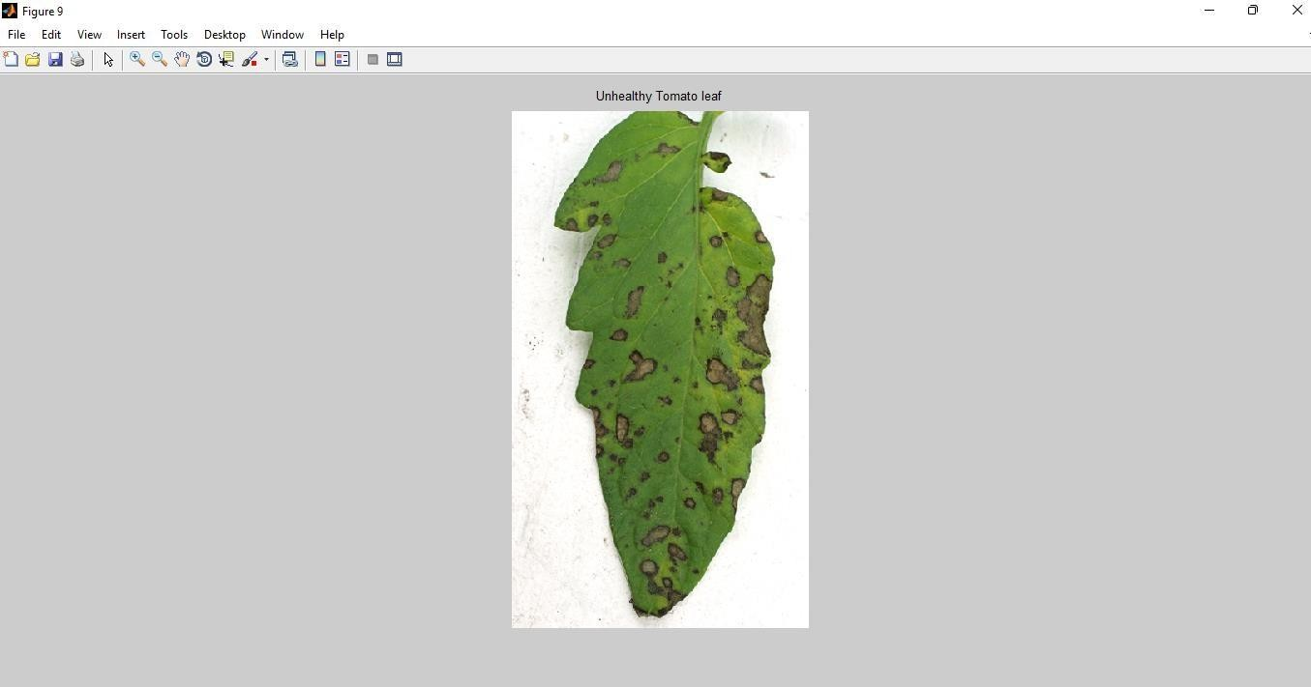

Fig. – 4.15 Shows the Unhealthy Tomato leaf used in the experiment of (Sample 2)
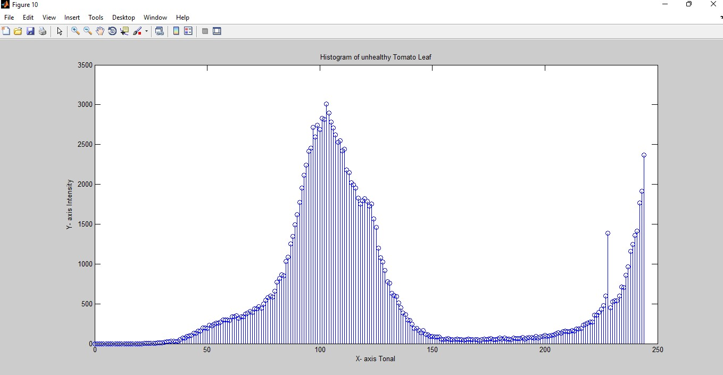

Fig. - 4.16 Shows the Histogram of Unhealthy Tomato leaf in which Y-Axis represents intensity whereas X-Axis shows represents the tonal (of sample-2)
CHAPTER-5
CONCLUSION AND FUTURE WORK

5.1 Conclusion

The automated identification of leaf diseases is a significant area of research in agriculture. It may be useful for keeping an eye on sizable agricultural areas and automatically identifying disease signs in plant leaves. Usually, the term "disease" refers solely to the death of living plants. This study offers a crucial new technique for identifying plant diseases. The techniques under investigation aim to treat plant diseases more accurately and throughput-wise than human prediction. An picture can be enhanced through the use of digital image processing. Image enhancement is the act of identifying hidden information in photographs and removing undesired distortion caused by deteriorating contrast, unwanted noise, inappropriate intensity saturation, blurring effect, etc. And image enhancement gives better visual images that are given as input to various digital image processing applications. At present, the work is only concentrated on the contrast enhancement of digital images that can be used in different applications like biometric analysis, pattern identification, facial acknowledgement, medical fields, and in consumer electronics applications. Contrast is an image element that could be defined as a ratio between the highest and the lowest pixel intensities of an image. In an image processing system contrast enhancement is a strenuous task to be done as well as it is very difficult to obtain a good contrast image. There are several descriptions for an image to have poor contrast or the poor quality of the used imaging device. The images usually suffer from poor image quality, degradation in contrast and happening of shading and artefacts, due to lack in cantering pixel intensity, poor lightening, specimen spotting and other factors that can be manipulated by image enhancement methods To improve agricultural products automatic detection of symptoms is beneficial.

A method for picture segmentation, which is employed for autonomous plant leaf disease detection and classification, is presented in this thesis. Surveys on various disease classification methods that might be applied to the identification of plant leaf diseases are also included. Genetic algorithms are used for image segmentation, acrucial step in the disease diagnosis process for plant leaf disease. Plant leaf of Rose and Tomato leaves has been considered the for methodology. The filter transforms the obtained leaf pictures into histogram format. Different textural characteristics, including mean, smoothness, contrast, etc. Plant diseases are identified using this collection of characteristics. The Minimum Distance Criterion is initially used to classify the data. After analysis, numerous leaf photos are looked at to determine whether they are healthy or unhealthy, and then the leaf images are filtered and histogram equalized.

REFERENCES

1. Crow W. T., & Dunn R. A. (2005). Introduction to Plant Nematology, ENY-016, Gainesville: University of Florida Institute of Food and Agricultural Sciences.

2. Crow W. T., & Woods F. E. (2007). Nematode Assay Laboratory, ENY-027, Gainesville: University of Florida Institute of Food and Agricultural Sciences.

3. Gyeltshen J., & Hodges A. (2006). Fuller Rose Beetle, Naupactus godmanni (Crotch) (Insecta: Coleoptera: Curculionidae),EENY-375,Gainesville: University of Florida Institute of Food and Agricultural Sciences.

4. Park Brown, S. (2007). Growing Roses in Florida, CIR344, Gainesville: University of Florida Institute of Food and Agricultural Sciences.

5. Kobayashi. K, (2002). "Birth of a Digital Photo Telegraph-the Bart lane System" Journal of the Institute of Image Electronics Engineers of Japan, 31(2), ISSN:
0285-9831.

6. Mukul S., Sajjan Singh, Nishi (2018). "The Origins of Digital Image Processing

& Application areas in Digital Image Processing Medical Images." NCEAM

2013, 1(2), ISSN: 2278-0181.

7. Sanjana S, Surya Narayan Ganguly, Dhara K N (2016). "A survey on image processing techniques in the field of agriculture." ICIOT – 2016, 4(29), ISSN:
2278-0181.

8. Martinez-Sandoval, J. R., Murillo-Bracamontes, E. A., Martinez-Rosas, M. E., Miranda Velasco, M. M., & Cervantes De Ávila, H. (2017). "Image processing applied in agriculture." ISBN: 978-953-51-3745-0.

9. Jayamala K. Patil, Raj Kumar (2011). "Advances in Image Processing For

Detection of Plant Diseases." JABAR, 2(2), ISSN- 0135-1141.

10. Suresh V., Mohana Krishnan, M. Hemavarshini, K. Jayanthan, D. Gopinath (2020). "Plant Disease Detection using Image Processing." IJERT, 9(3). ISSN: 2278-0181

11. Shelar N., Shinde S., Sawant S., Dhumal S., & Fakir, K. (2022). "Plant Disease

Detection Using CNN." ITM Web of Conference, 32 (2023), ISSN-2455-4855.

12. Kavitha A. (2021). "Deep learning in agriculture" IJERT, 2021, 9(5), ISSN- 2278-

0181.

13. Vandana B, S Sathish Kumar "Hybrid K mean clustering algorithm for crop production analysis in agriculture.” IJITEE, 9(3), ISSN: 2278-3075.

14. Gonzalez R. C., & Woods R. E. (2002). Digital Image Processing, 2nd edition.

Prentice Hall.

15. Al-Hiary, H. Bani-Ahmad, S. Reyalat, M. Braik, M. & Alrahamneh, Z. (2011). "Fast and Accurate Detection and Classification of Plant Diseases." IJCA, 17(1), ISS: 0975 – 8887.

16. Chaudhary P., Chaudhari A. K., Cheeran, A. N., & Godara, S. (2012). "Color

Transform Based Approach for Disease Spot Detection on Plant leaf." IJCST,

3(6), ISSN 2047-3338.

17. Revathi P., & Hemalatha M. (2012). "Classification of cotton leaf spot diseases using image processing edge detection techniques." 2012 International Conference on Emerging Trends in Science, Engineering and Technology (INCOSET). ISBN: 978-1-4673-5141-6, IEEE Publication.

